AMERICAN INTERNATIONAL UNIVERSITY - BANGLADESH (AIUB)
FACULTY OF SCIENCE & TECHNOLOGY


Course Title
INTRODUCTION TO DATABASE (CSC2108)

Semester: Fall 2024-2025
Section: [W]

TITLE
University Management System

Supervised By
Nyme Ahmed
Lecturer, Department of Computer Science

Submitted By: Group no: 11
Name | ID
- MD. JARIFUR RAHMAN | 23-55463-3
- MD. TANVIR HASAN | 23-54796-3
- RUBIA ISPA HRIDE | 23-53606-3

TABLE OF CONTENTS

TOPICS |  | Page no.
Title Page |  | 1
Table of Content |  | 2
1. | Introduction | 3
2. | Case Study | 3
3. | ER Diagram | 4
4. | Normalization | 5-11
5. | Finalization | 12
6. | Table Creation | 12-22
7. | Data Insertion | 23-27
8. | Query Test | 28-39
9. | DB connection | 40-47

Introduction

In a university, effective management of academic tasks is crucial for ensuring smooth operations. A comprehensive university management system keeps track of various elements—such as students, teachers, departments, courses, and classrooms—each with its own detailed information and interconnections. This integration not only enhances data accuracy but also streamlines administrative processes, contributing to a more efficient academic environment.

Case Study / Scenario

In a university management system, students are the heart of the system. Many students belong to one department, and each student is uniquely identified by a Student ID. They have personal details such as Name, Date of Birth (DOB), Address, City, Contact Phone Number, and Department ID. A faculty member belongs to only one department and has a unique Faculty ID along with their Name, Phone Number, and Email, as well as the Department ID they are associated with. Many students are also associated with one faculty member. Departments offer many courses, with each department being uniquely identified by a Department ID and having a Department Name. A faculty member can teach many courses, and each course is uniquely identified by a Course ID. In addition to the Course Name and the specified number of Credits, each course includes extra details such as Faculty ID, Classroom ID, and Department ID. Many courses are taken by many students, establishing a many-to-many Relationship. Courses are also conducted in classrooms, where each classroom is uniquely identified by a Classroom ID, has a Room Number, and is located in a specific Building.

ER Diagram

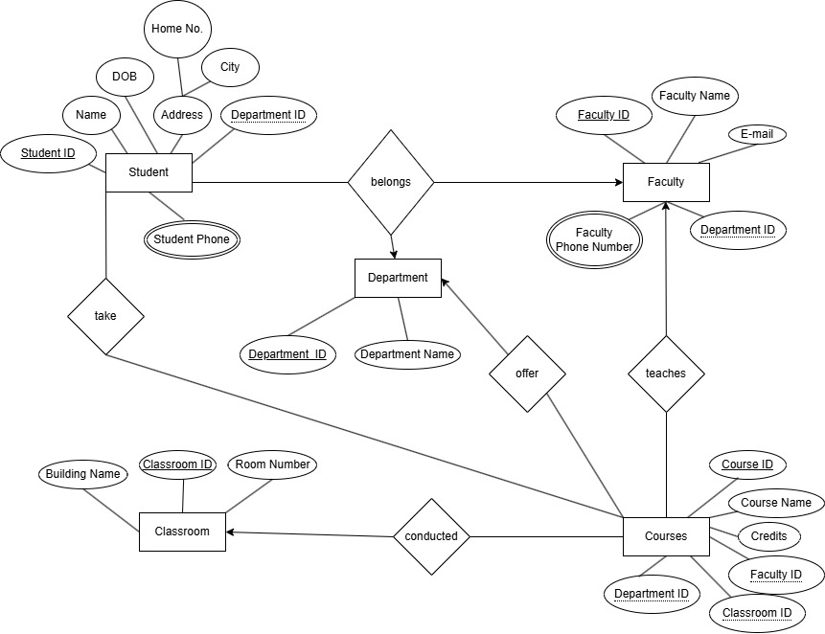

Normalization

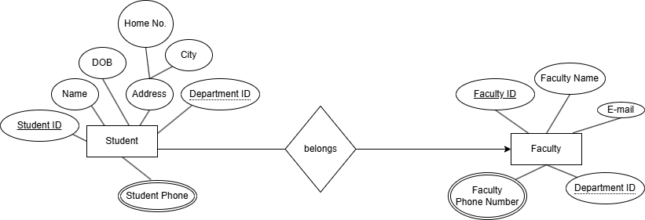

Relation: Many to one.
UNF: Student ID, Name, DOB, Home No., City, Department ID , Faculty ID , Faculty Name, Faculty Phone Number, E-mail, Department ID , Student Phone.
1NF: Multivalued attributes: Student Phone, Faculty Phone Number.
Student ID, Name, DOB, Department ID , Faculty ID , Faculty Name, E-mail, Home No., City,
2NF:
1. Faculty ID, Faculty Phone Number.
2. Student ID, Student Phone.
3. Student ID, Name, DOB, Home No., City, Department ID , Faculty ID (Foreign Key)
4. Faculty ID, Faculty Name, E-mail, Department ID .
3NF:
1. Faculty ID, Faculty Phone Number.
2. Student ID, Student Phone.
3. Student ID, Home No., City.
4. Student ID, Name, DOB, Department ID, Faculty ID (Foreign Key)
5. Faculty ID, Faculty Name, E-mail, Department ID.

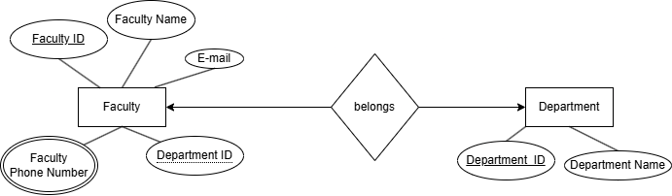

Relation: One to one.
UNF: Faculty ID, Faculty, Faculty Name, Faculty Phone Number, Department ID, E-mail, Department Name.
1NF: Multivalued attributes: Faculty Phone Number.
Faculty ID, Faculty Name, Department ID, E-mail, Department Name, Department ID.

2NF:
1. Faculty ID, Faculty Phone Number.
2. Faculty ID, Faculty Name, E-mail, Department Name.
3. Department ID, Department Name, Faculty ID (Foreign Key)

3NF:
1. Faculty ID, Faculty Phone Number.
2. Faculty ID, Faculty Name, E-mail, Department ID
3. Department ID, Department Name, Faculty ID (Foreign Key)

3.
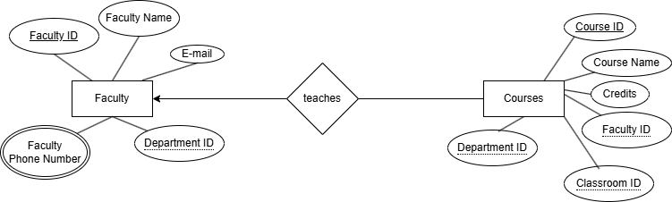

Relation: One to many
UNF: Faculty ID, Faculty Name, E-mail, Department ID, Faculty Phone Number, Department ID, Course ID, Classroom ID, Faculty ID, Credits, Course Name, Department ID.
1NF: Multivalued attributes: Faculty Phone Number.
1. Faculty ID, Faculty Name, E-mail, Department ID, Course ID, Department ID, Classroom ID, Credits, Course Name, Faculty ID.
2NF:
1. Faculty ID, Faculty Phone Number.
2. Faculty ID, Faculty Name, E-mail, Department ID.
3. Course ID, Department ID, Classroom ID, Faculty ID, Credits, Course Name, Faculty ID (Foreign Key)

3NF:
1. Faculty ID, Faculty Phone Number.
2. Faculty ID, Faculty Name, E-mail, Department ID.
3. Course ID, Credits, Course Name, Department ID, Classroom ID, Faculty ID.

4.
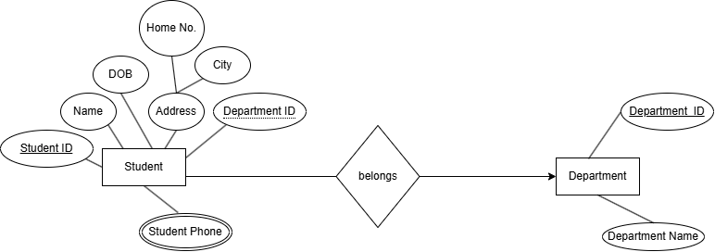
Relation: Many to one.
UNF: Student ID, Name, DOB, Home No, City, Student Phone, Department ID, Department Name, Department ID.
1NF: Multivalued attributes: Student Phone.
Student ID, Name, DOB, Home No, City, Department ID, Department Name, Department ID.
2NF:
1. Student ID, Student Phone.
2. Student ID, Name, DOB, Home No, City, Department ID, Department ID (Foreign Key)
3. Department ID, Department Name.

3NF:
1. Student ID, Student Phone.
2. Student ID, Home No., City
3. Student ID, Name, DOB, Department ID, Department ID (Foreign Key)
4. Department ID, Department Name.

5.
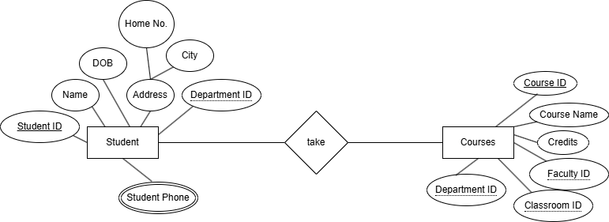
Relation: Many to many.
UNF: Course ID, Course Name, Credits, Department ID, Classroom ID, Faculty ID, Student ID, Name, DOB, Home No, City, Department ID

1NF: Course ID, Course Name, Credits, Department ID, Classroom ID, Faculty ID, Student ID, Name, DOB, Home No, City, Department ID
2NF:
1. Course ID,Course Name, Credits, Department ID, Classroom ID, Faculty ID, Student ID (Foreign Key)
2. Student ID, Name, DOB, Home No, City, Department ID, Home No, City.
3NF:
1. Course ID, Course Name, Credits, Department ID, Classroom ID, Faculty ID, Student ID (Foreign Key)
2. Student ID, Home No, City.
3. Student ID, Name, DOB, Department ID.

6.

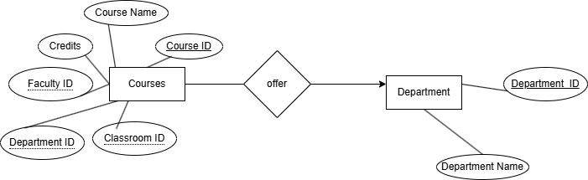

Relation: Many to one.
UNF: Course ID, Course Name, Credits, Faculty ID, Classroom ID, Department ID, Department ID, Department Name.

1NF: Course ID, Course Name, Credits, Faculty ID, Classroom ID, Department ID, Department ID, Department Name.
2NF:
1. Course ID, Course Name, Credits, Faculty ID, Classroom ID, Department ID, Department ID (Foreign key)
2. Department ID, Department Name.
3NF:
1. Course ID, Course Name, Credits, Faculty ID, Classroom ID, Department ID, Department ID (Foreign Key)
2. Department ID, Department Name.

7.
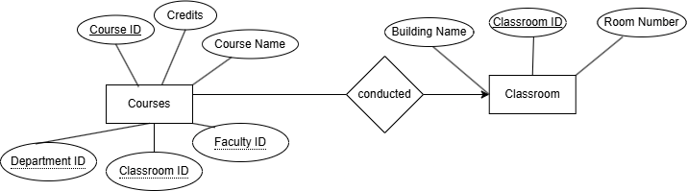

Relation: Many to one.
UNF: Course ID, Course Name, Credits, Classroom ID, Department ID, Faculty ID, Classroom ID, Building Name, Room Number.

1NF: Course ID, Course Name, Credits, Classroom ID, Department ID, Faculty ID, Classroom ID, Building Name, Room Number.
2NF:
1. Course ID, Course Name, Credits, Department ID, Faculty ID, Classroom ID, Classroom ID (Foreign Key)
2. Classroom ID, Building Name, Room Number.
3NF:
1. Course ID, Course Name, Credits, Faculty ID, Classroom ID, Department ID, Classroom ID (Foreign Key)
2. Classroom ID, Building Name, Room Number.

Finalization

1. Faculty ID, Faculty Phone Number.
2. Student ID, Student Phone.
3. Student ID, Home No., City
4. Student ID, Name, DOB, Home No, City, Department ID, Faculty ID (Foreign Key)
5. Faculty ID, Faculty Name, E-mail, Department ID.
6. Student ID, Student Phone.
7. Student ID, Home No., City
8. Student ID, Name, DOB, Department ID, Department ID (Foreign Key)
9. Department ID, Department Name.
10. Faculty ID, Faculty Phone Number.
11. Faculty ID, Faculty Name, E-mail, Department ID.
12. Department ID, Department Name, Faculty ID (Foreign Key)
13. Faculty ID, Faculty Phone Number.
14. Faculty ID, Faculty Name, E-mail, Department ID.
15. Course ID, Credits, Course Name, Department ID, Classroom ID, Faculty ID.
16. Course ID, Credits, Course Name, Department ID, Classroom ID, Faculty ID, Department ID (Foreign Key)
17. Department ID, Department Name.
18. Course ID, Credits, Course Name, Department ID, Classroom ID, Faculty ID, Student ID (Foreign Key)
19. Student ID, Home No., City.
20. Student ID, Name, DOB, Department ID.
21. Course ID, Credits, Course Name, Department ID, Classroom ID, Faculty ID, Classroom ID (Foreign key)
22. Classroom ID, Building Name, Room Number.

Final Table

1. Faculty ID, Faculty Phone Number.
2. Student ID, Student Phone.
3. Student ID, Home No, City.
4. Student ID, Name, DOB, Department ID, Faculty ID (Foreign Key)
5. Faculty ID, Faculty Name, E-mail, Department ID.
6. Student ID, Name, DOB, Department ID (Foreign Key)
7. Department ID, Department Name, Faculty ID (Foreign Key)
8. Course ID, Course Name, Credits, Department ID, Classroom ID, Faculty ID, Student ID (Foreign Key)
9. Classroom ID, Building Name, Room Number.

Table Creation (DDL Operations)

Student ID: 23-55463-3 Name: MD. JARIFUR RAHMAN | Student ID: 23-54796-3 Name: MD. TANVIR HASAN
Student ID: 23-53606-3 Name: RUBIA ISPA HRIDE | Student ID: N/A Name: N/A
CO4: Creating DML, DDL using Oracle and connection with ODBC/JDBC for existing JAVA application
PO-e-2: Use modern engineering and IT tools for prediction and modeling of complex computer science and engineering problem |  | Marks

1. Faculty Contact Table
Create table faculty_contuct (faculty_id int primary key,faculty_phone_number int)
desc faculty_contuct
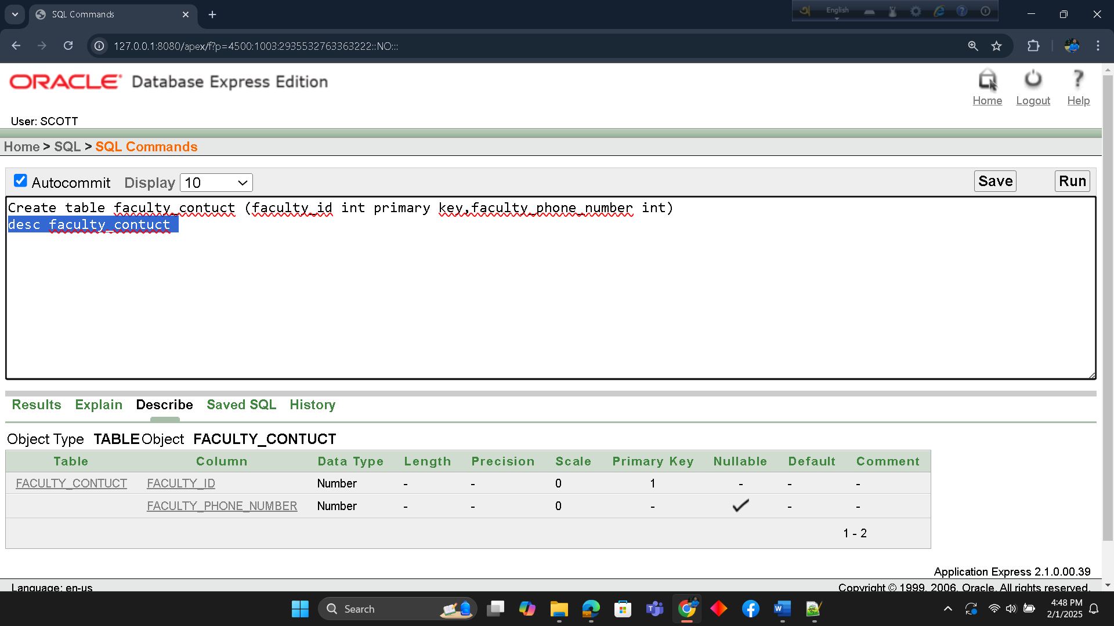

2. Student Contact Table
Create table student_contuct (student_id int primary key,student_phone int)
desc student_contuct

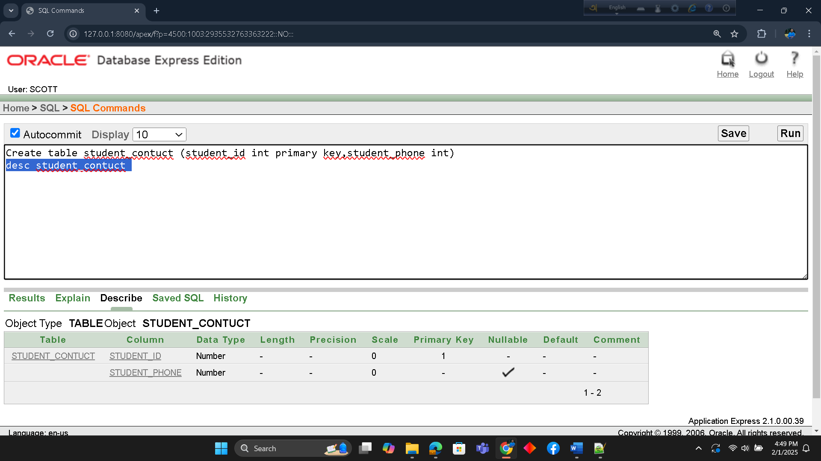

3. Student Address Table
Create table student_address (student_id int primary key,home_no varchar(100),city varchar(200))
desc student_address

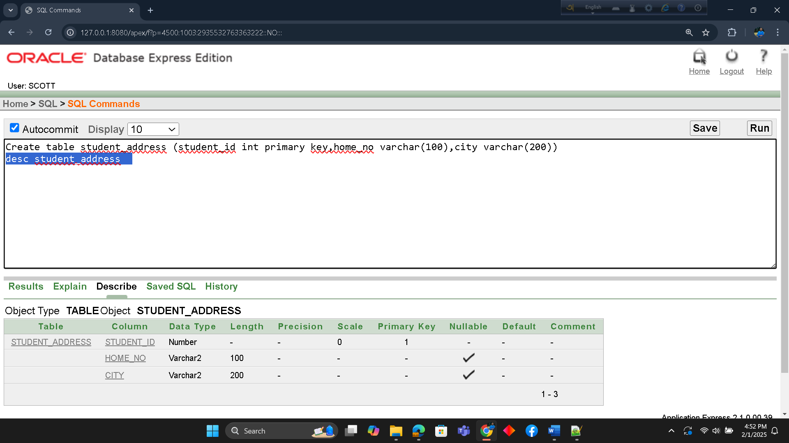

4. Student Information Table
Create table student_information
(student_id int primary key,name varchar2(100),DOB varchar2(100),Department_id number(10),faculty_id number(10))
alter table student_information add constraint t4 foreign key(faculty_id) references faculty_contuct(faculty_id)
desc student_information

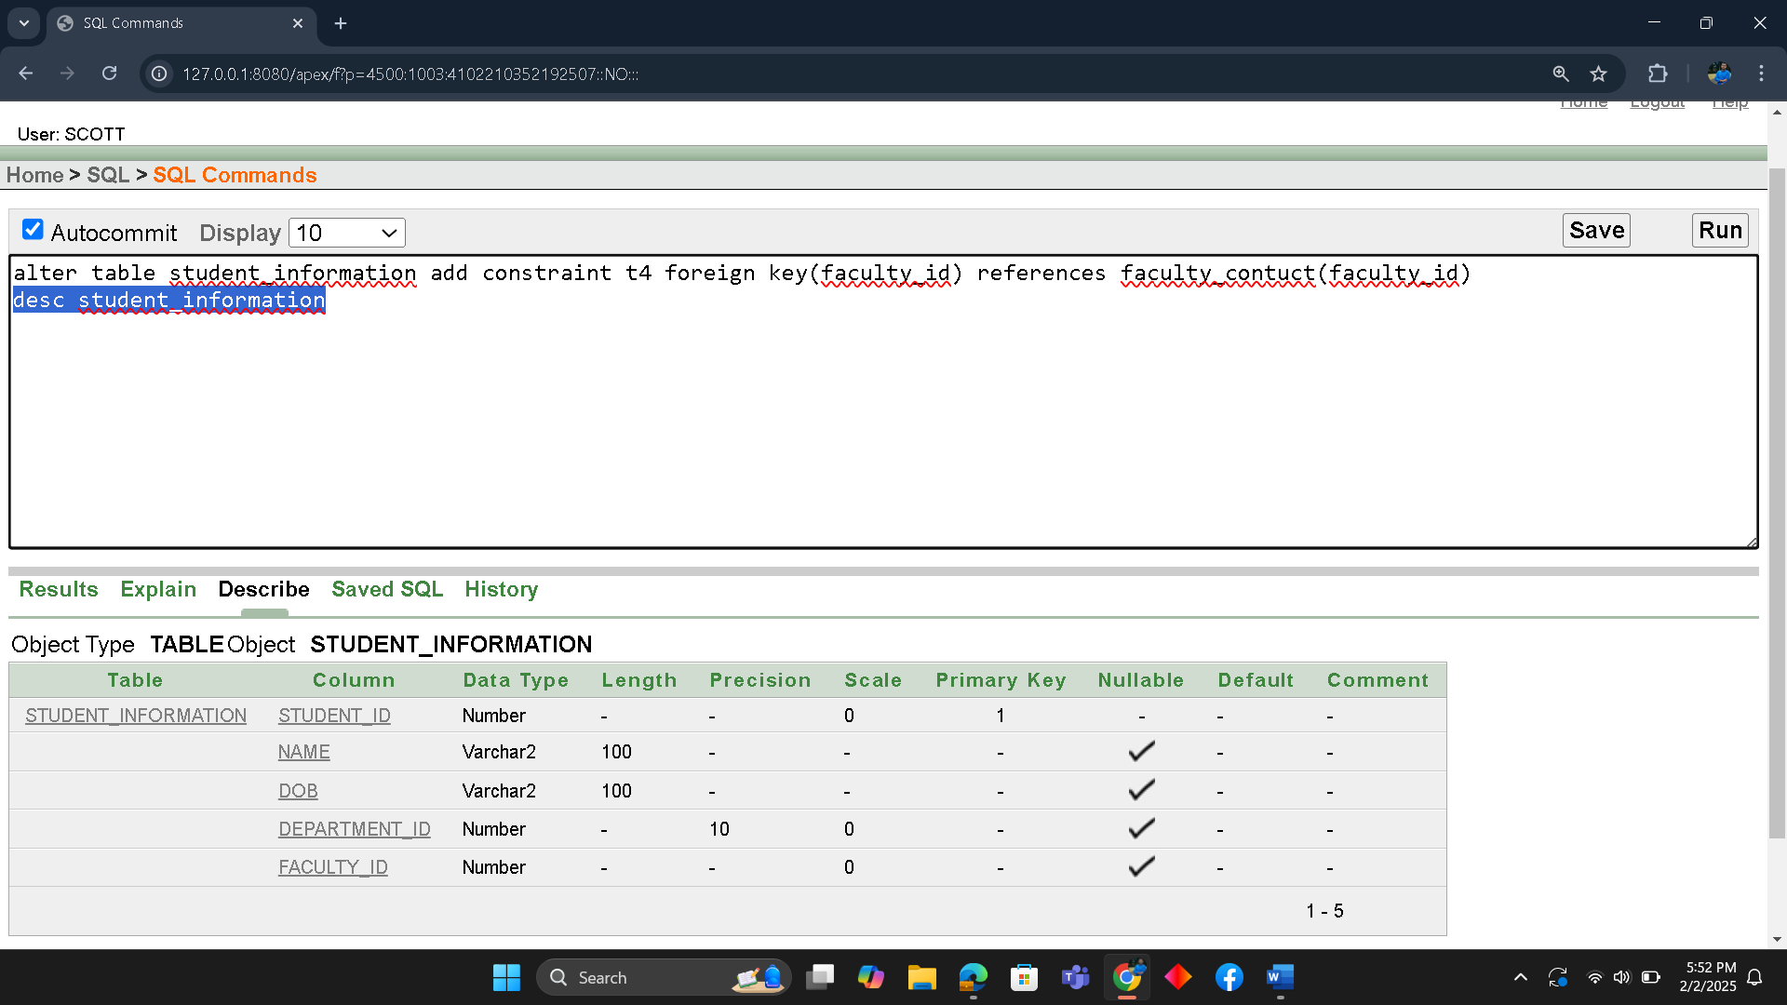

5. Faculty Information Table
Create table faculty_information
(faculty_id int primary key,faculty_name varchar2(100),email varchar2(100),Department_id number(10))
desc faculty_information

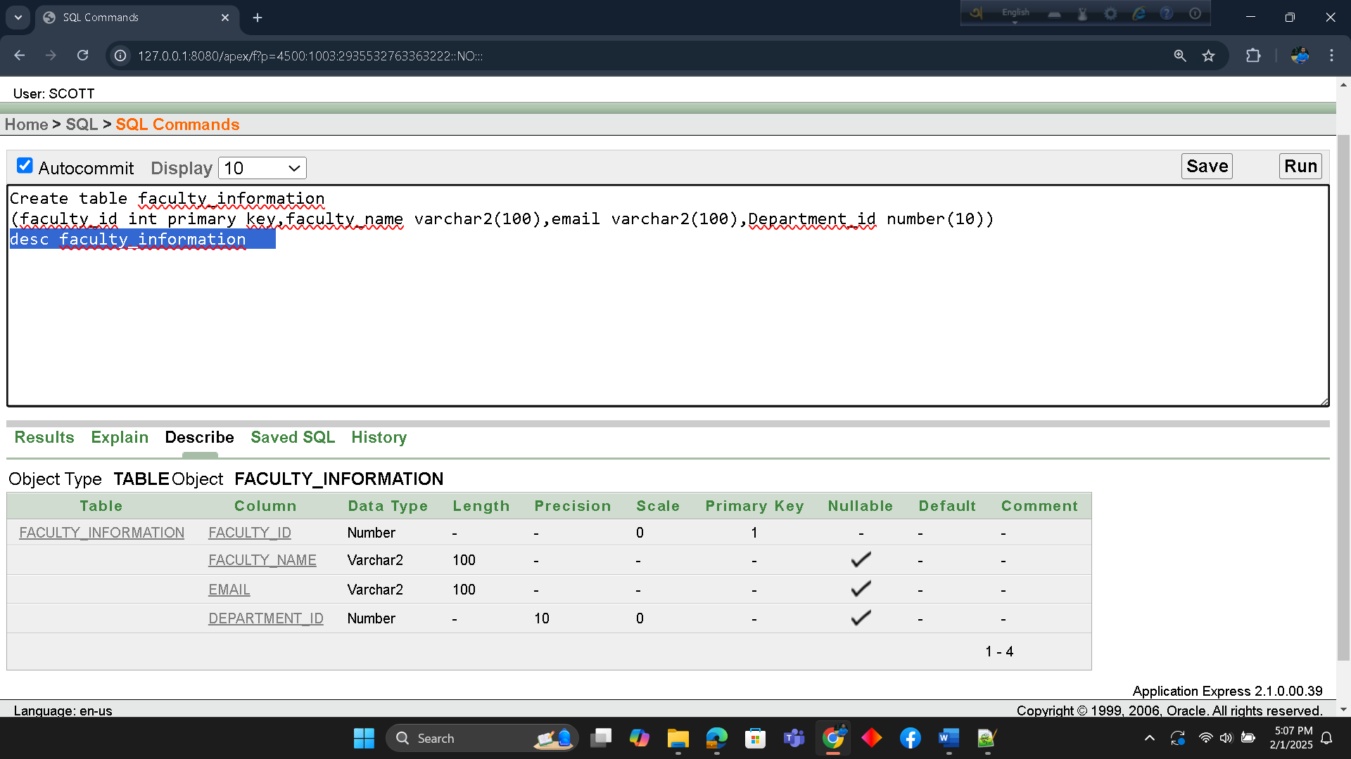

6. Student and Department Information Table

Create table student_department_information
(student_id primary key,name varchar2(100),DOB varchar2(100),department_id_number(10))
Alter table student_department_information add constraint t6 foreign key(department_id) references department_information(department_id)
desc student_department_information
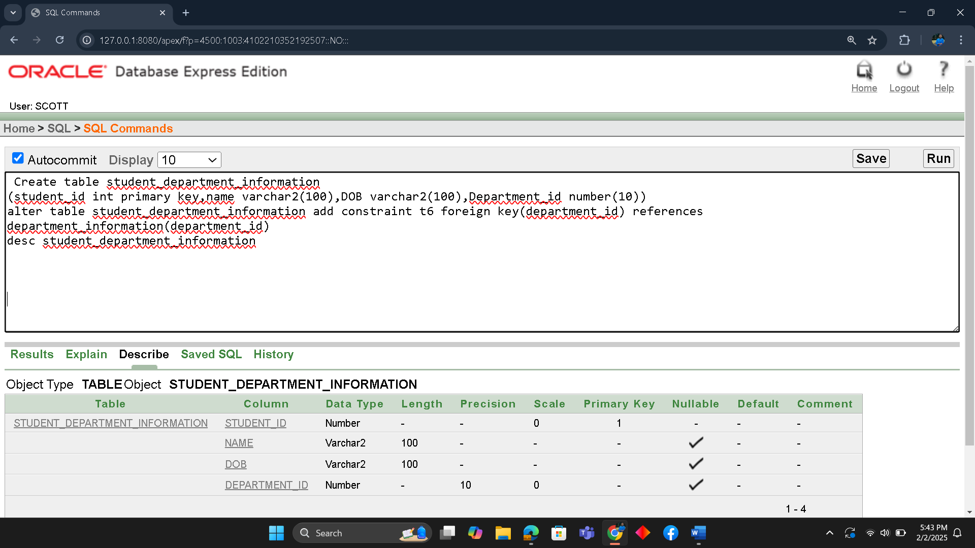

7. Department Information Table

Create table deparment_information
(deparment_id int primary key,department_name varchar2(100),faculty_id int)
alter table department_information add constraint t7 foreign key(faculty_id) references faculty_contuct(faculty_id)
desc department_information
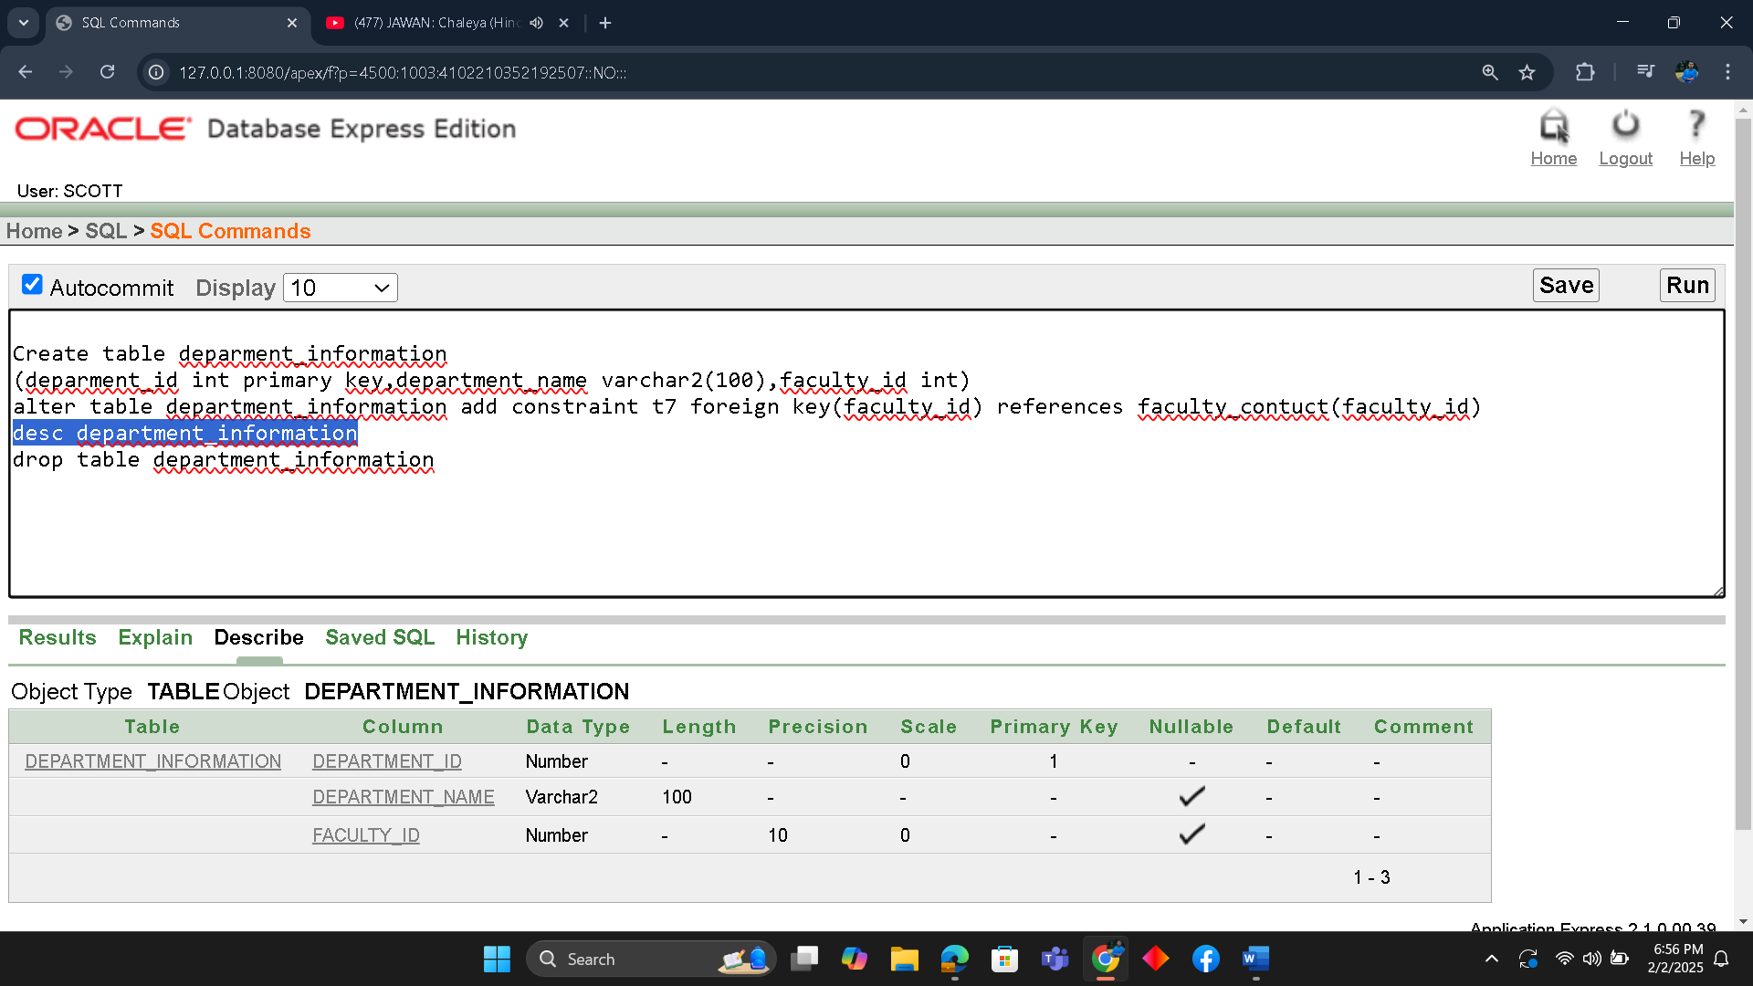

8. Course Information Table
Create table course_information
(course_id int primary key,course_name varchar2(100),course_credits number(10),department_id number(10),clasroom_id number(10),faculty_id number(10),student_id int)
alter table course_information add constraint t9 foreign key(student_id) references student_contuct(student_id)
desc course_information

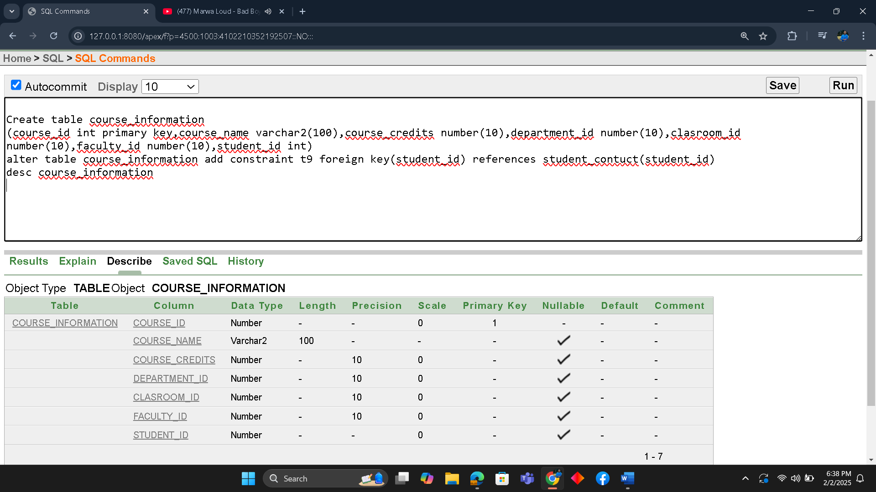

9. Classroom Information Table

Create table classroom_information
(classroom_id int primary key,building_name varchar2(100),room_number varchar2(100))
desc classroom_information

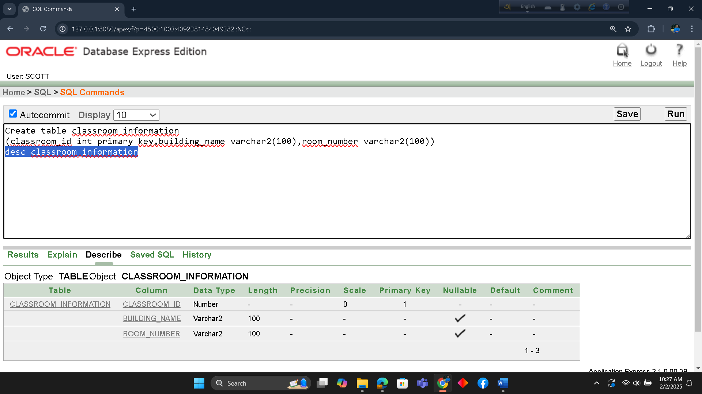

Inserted Values in the tables
1.
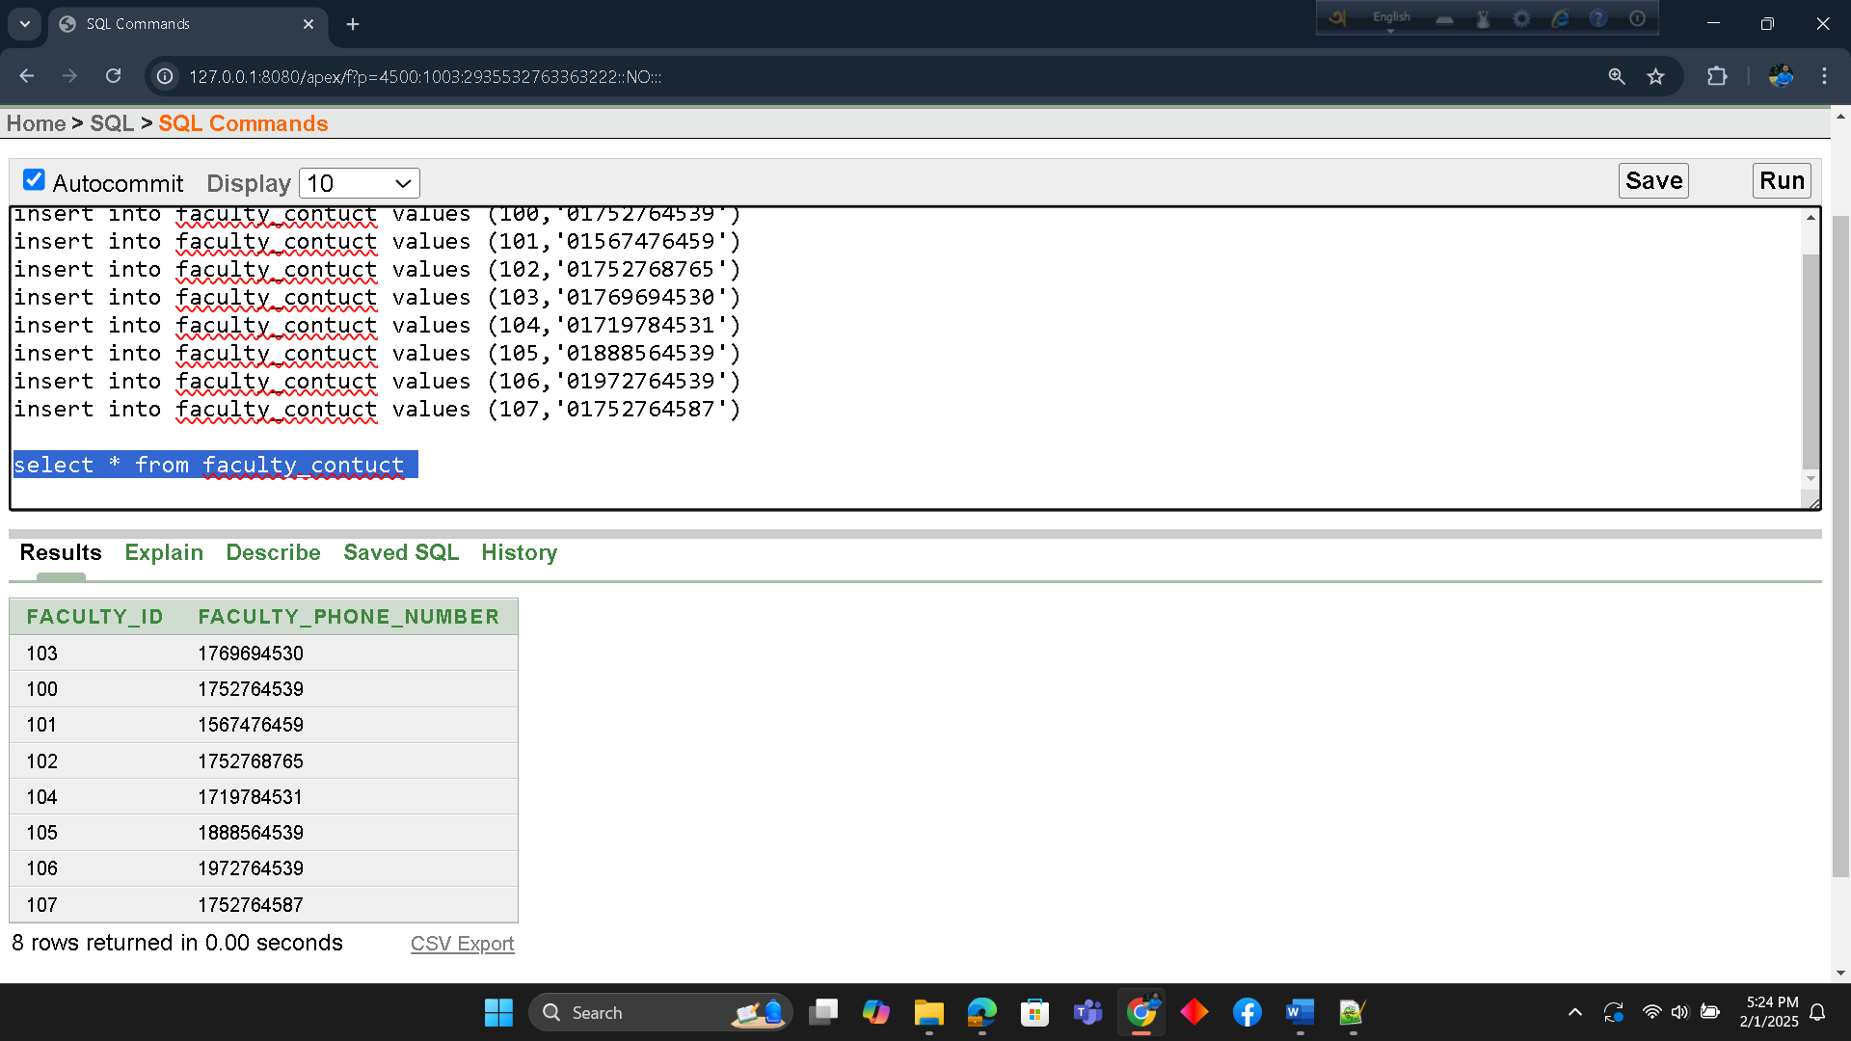
2.
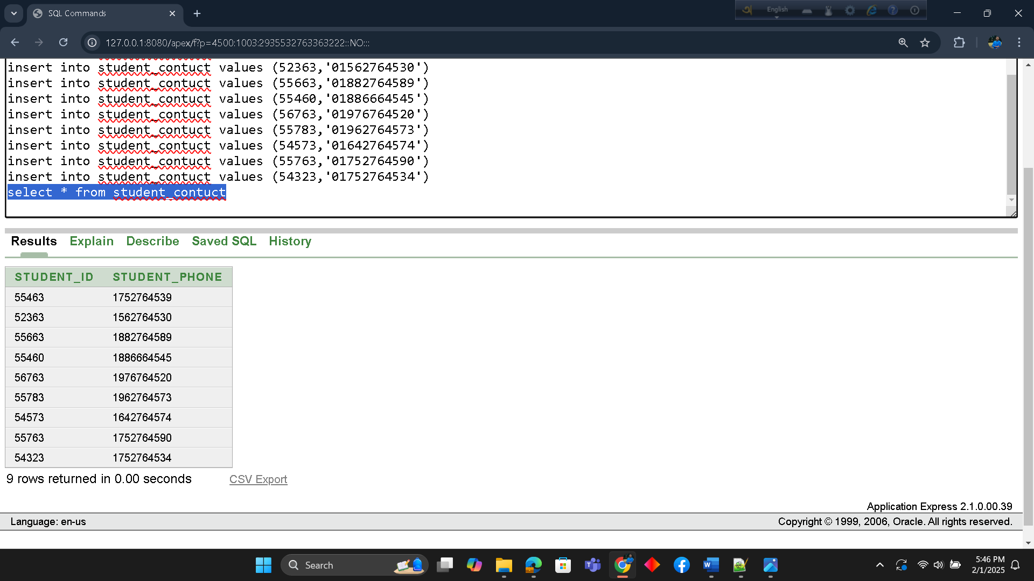
3.
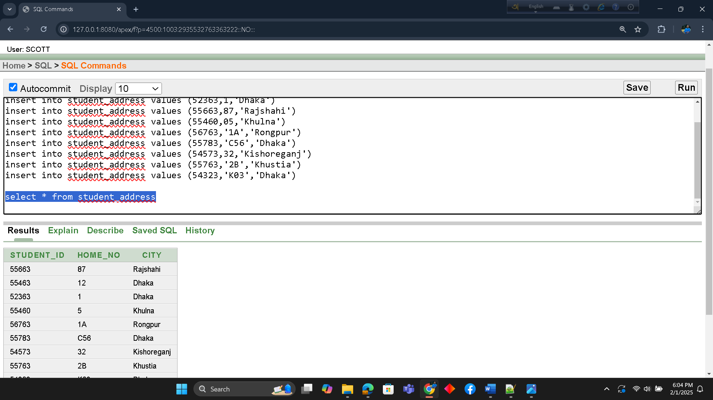

4.
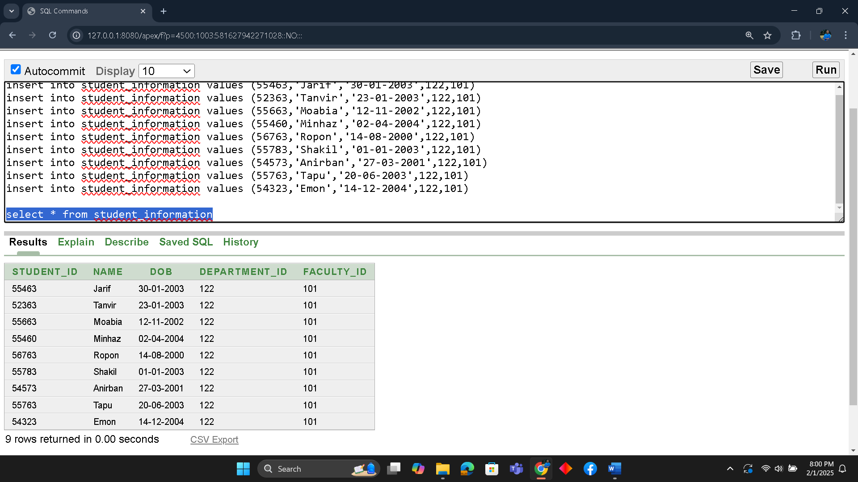

5.
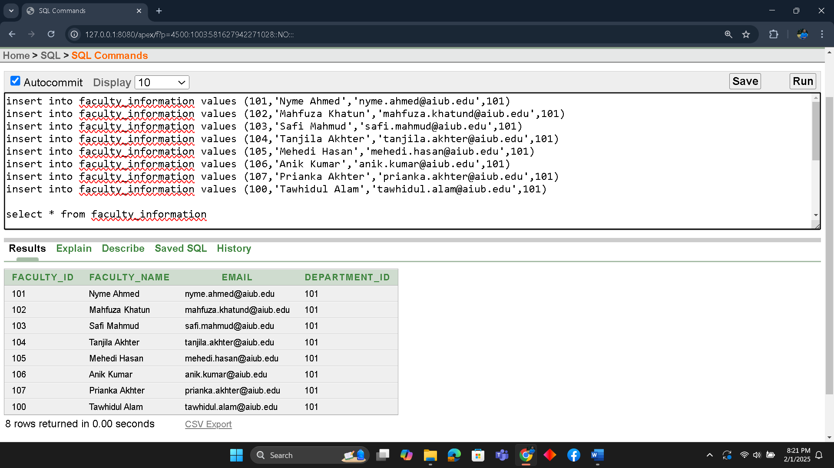

6.
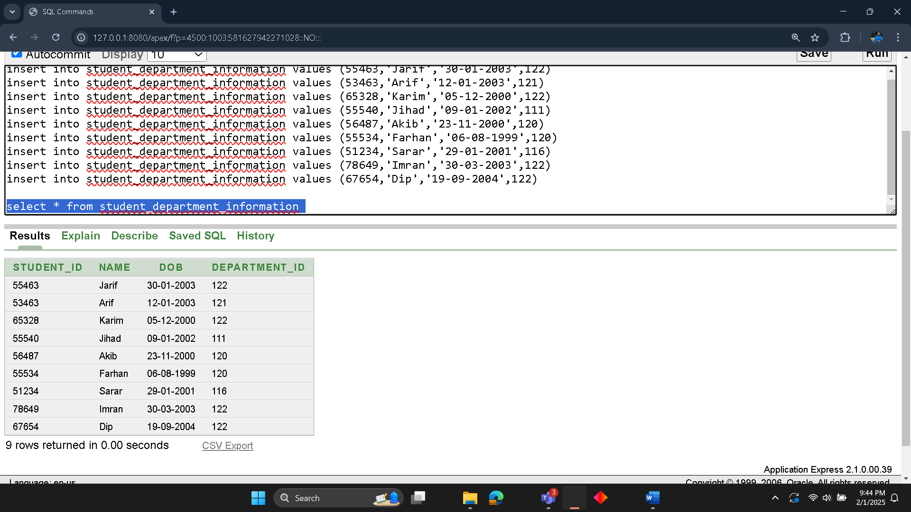
7.
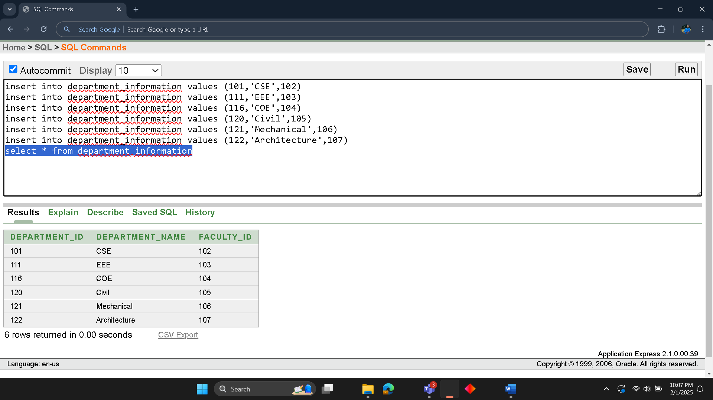

8.
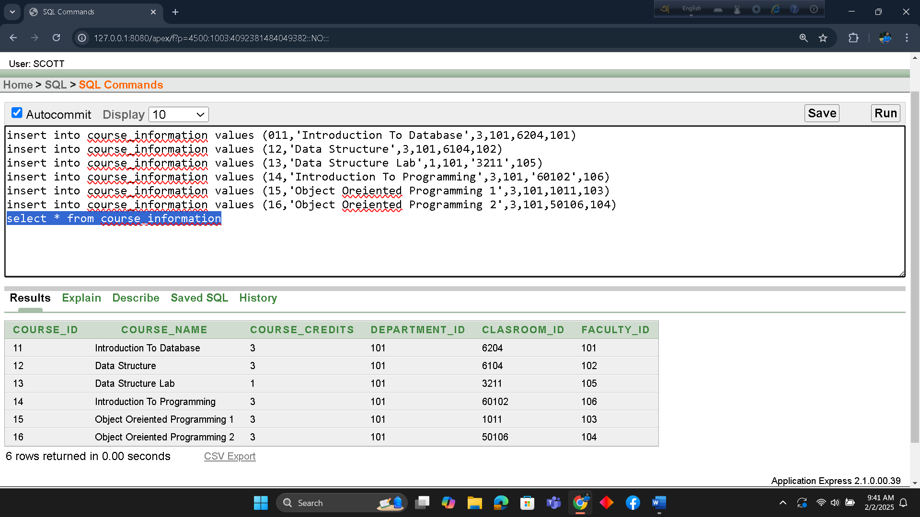

9.
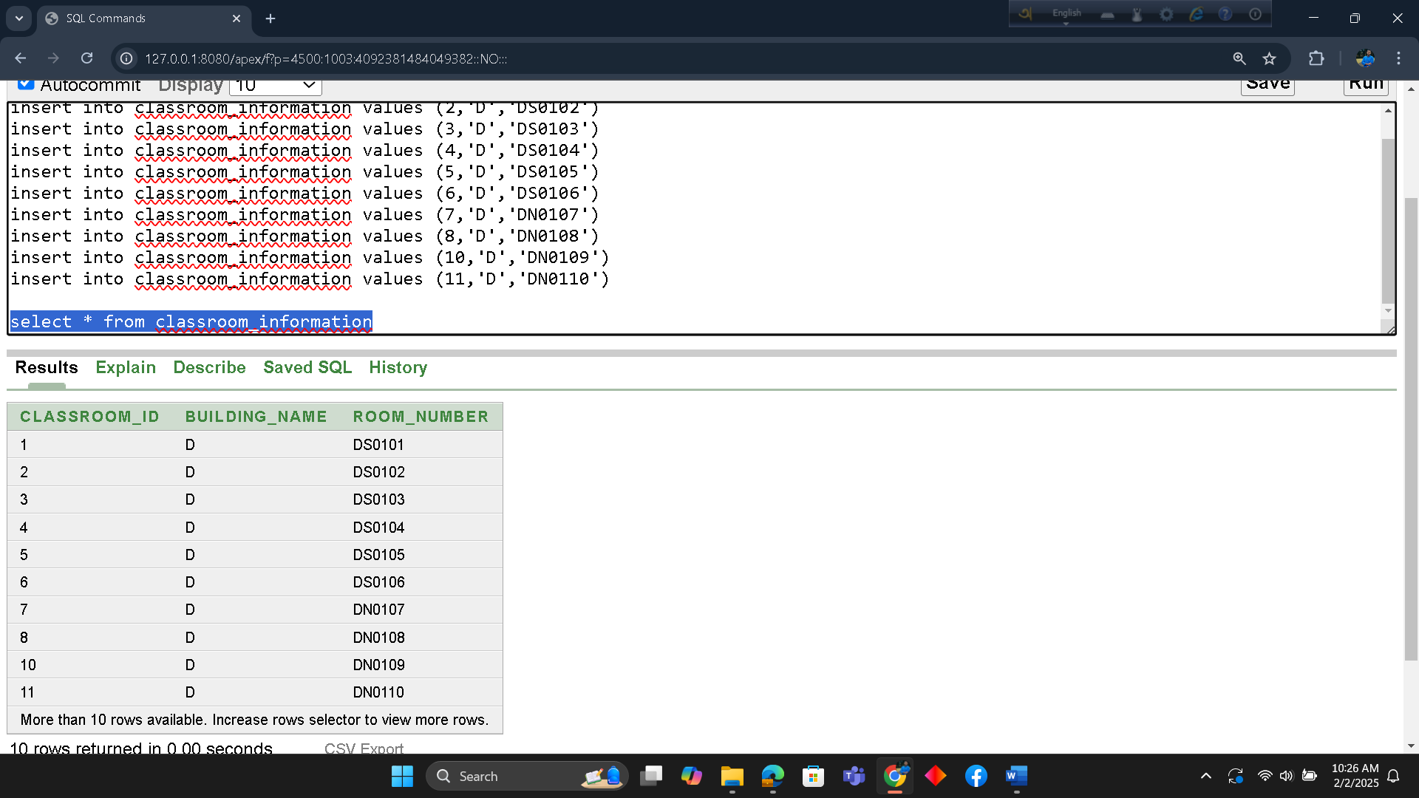

QUERY TEST IN DATABASE

a) Simple query
Show all the informations of faculty.
select * from faculty_information

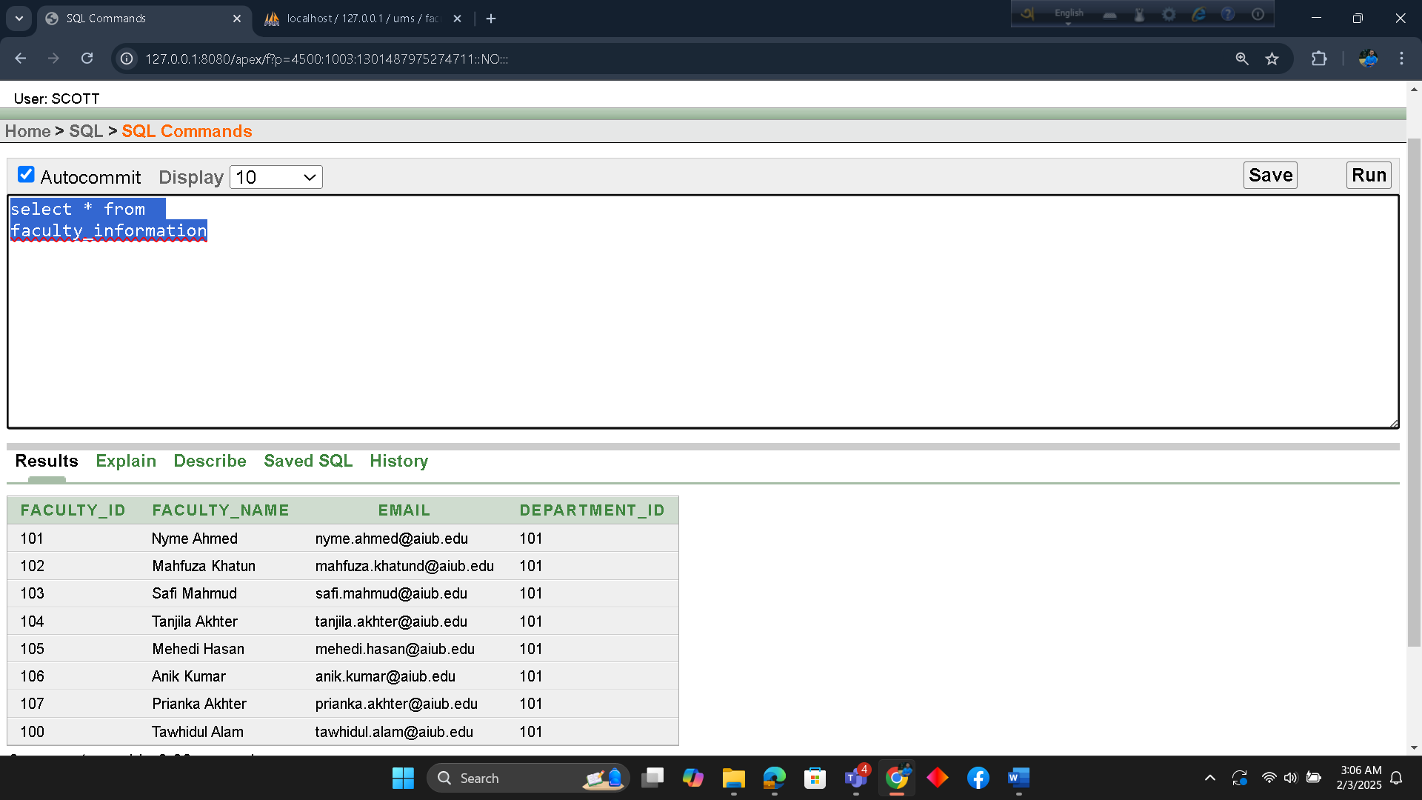

b) Query with a single row function
Show all the email addresses of faculty in single row.
select faculty_name || ' and Email: ' || email as "Faculty Email"
from faculty_information

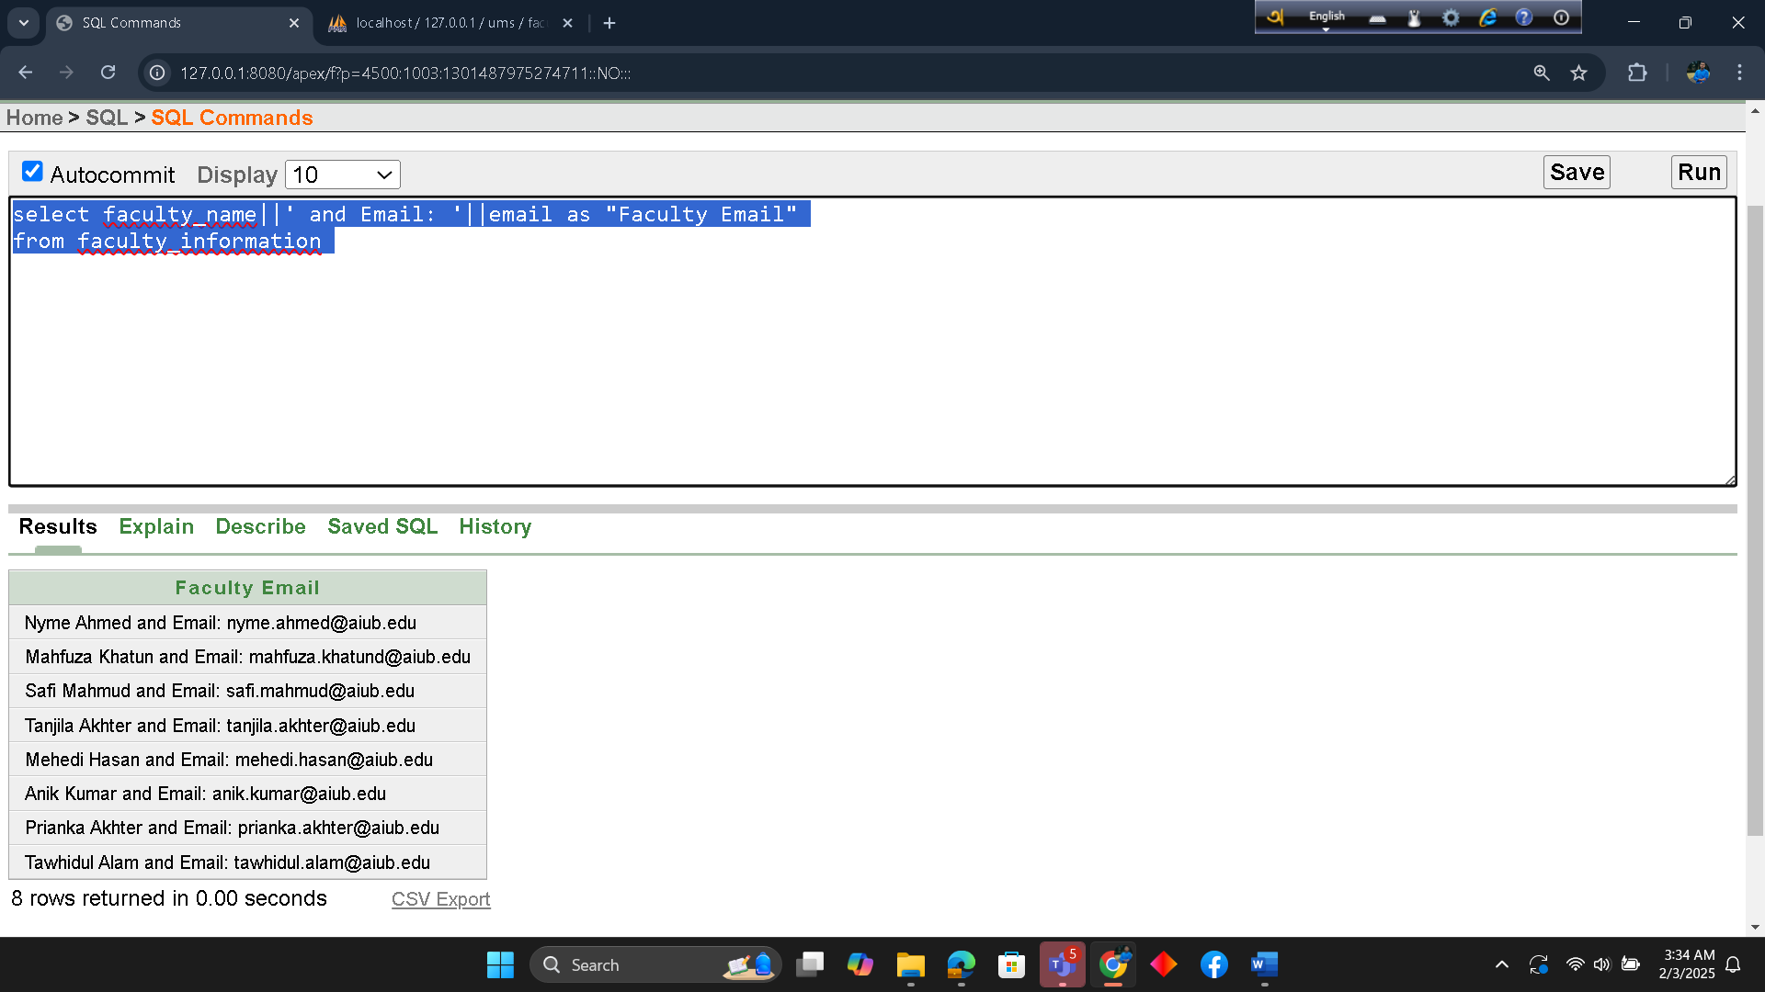

c) Query with a Multiple row function/ aggregate function
Count faculty members and find the first & last names alphabetically.
select count(*) as total_faculty
min(faculty_name) as first_faculty_alphabetically
min(faculty_name) as last_faculty_alphabetically
from faculty_information

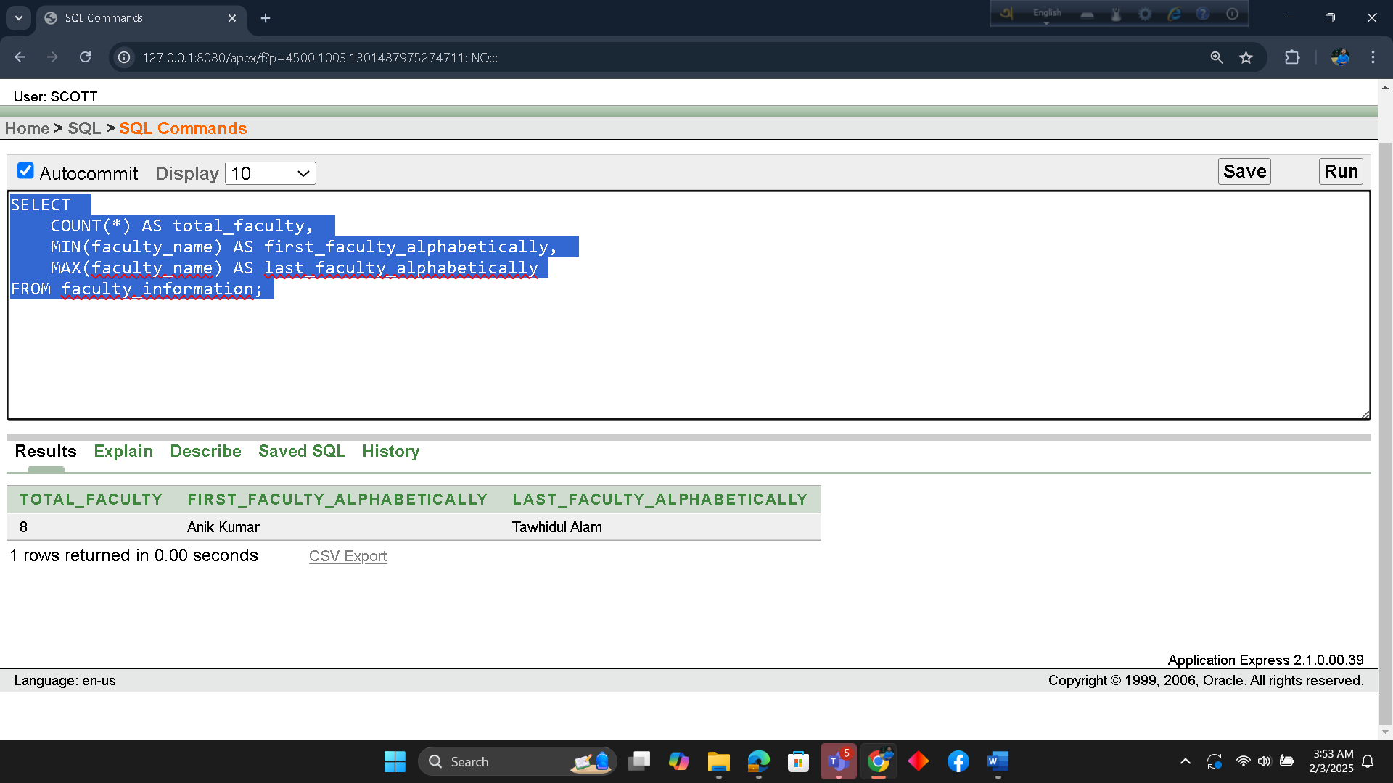

d) 2 Single row subquery and 2 multiple row subquery
Single row subquery 01 :

Find the student(s) who belong to the same department as the student named 'Imran'.

select * from student_department_information
where department_id = ( select department_id from student_department_information
where name = 'Imran')

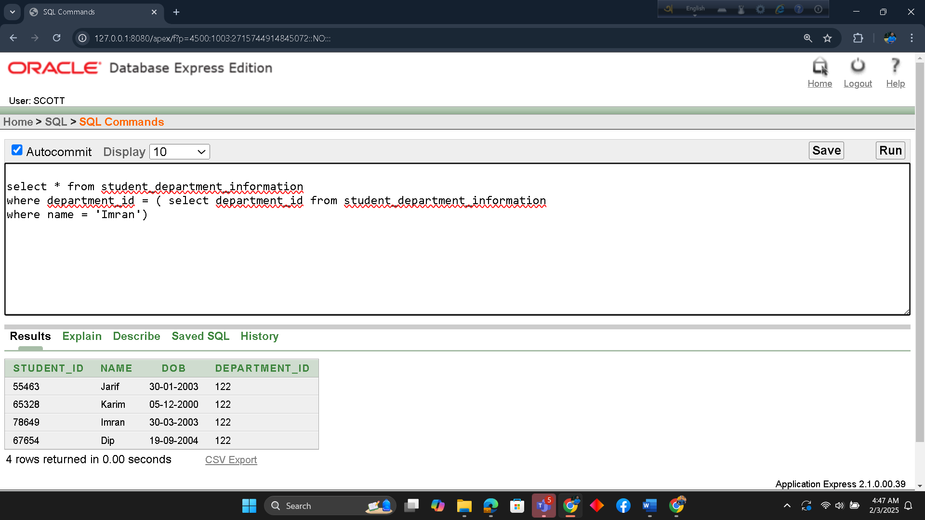

Single row subquery 02 :

Find the students who live in the same city as the student with student_id = 54323.

select *
from student_address
where city = (select city from student_address where student_id = 54323)
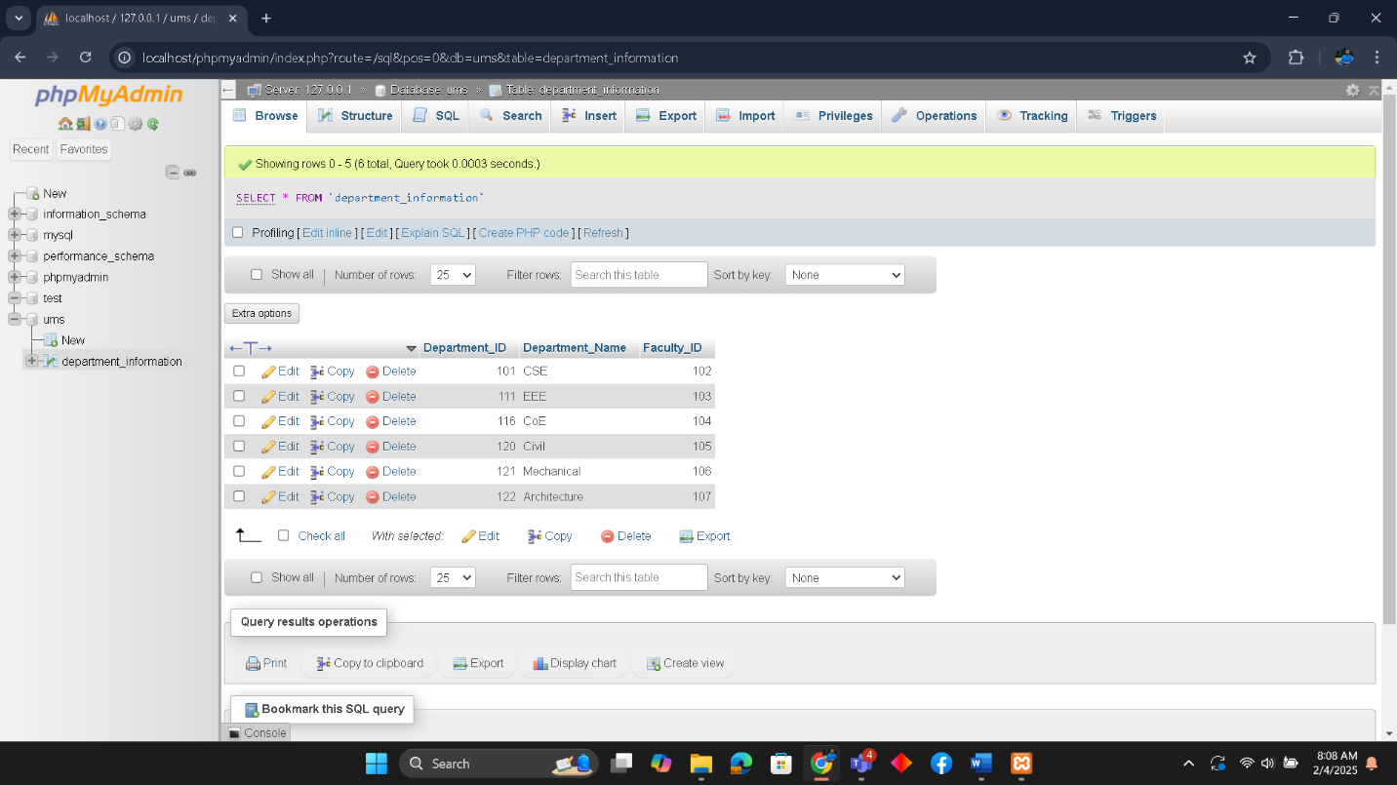

Multiple row subquery 01:

Find all departments that have a faculty_id greater than the faculty_id of all departments.

select *
from department_information
where faculty_id > (select avg(faculty_id) from department_information)

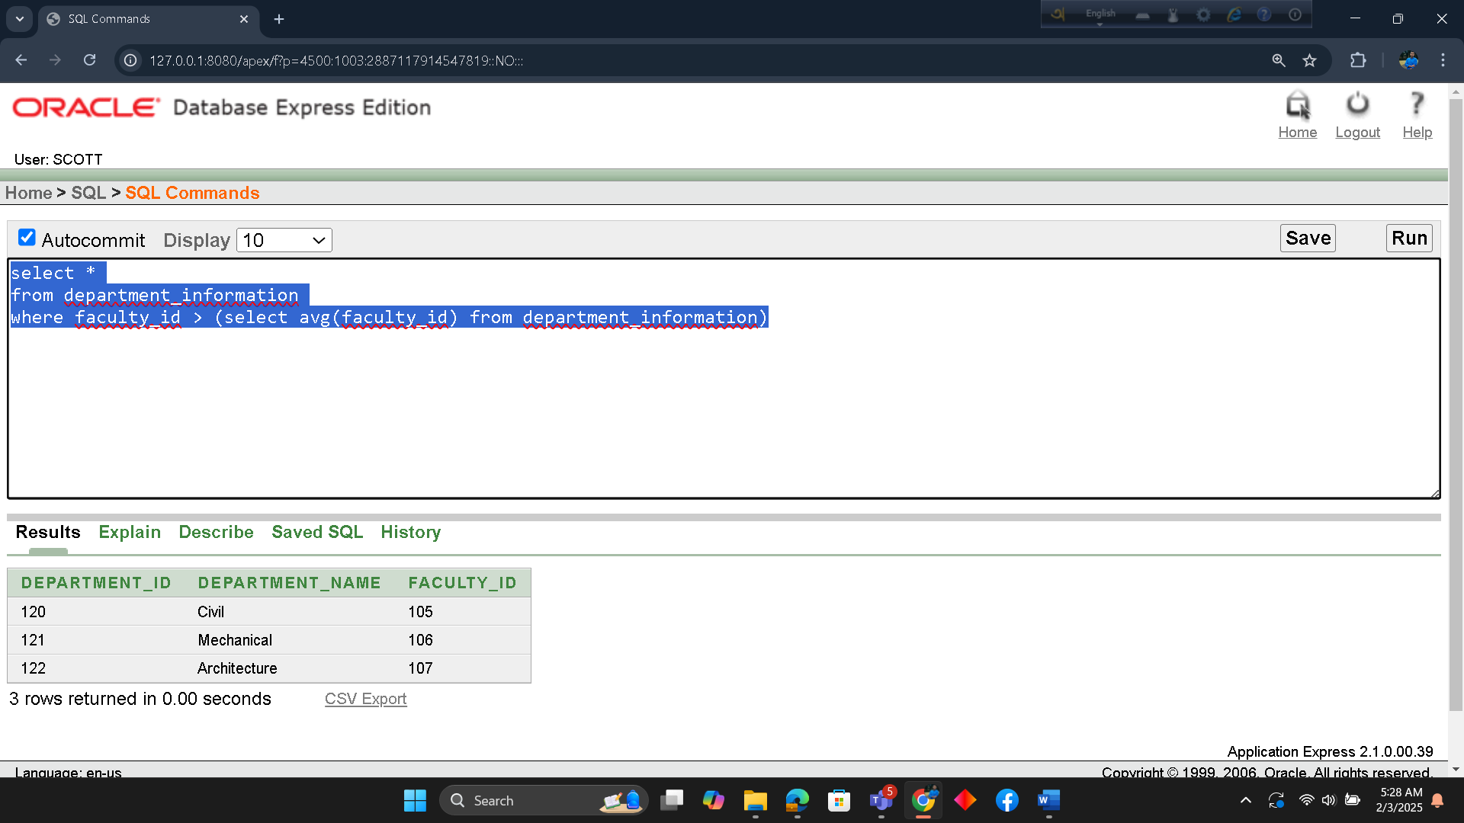

Multiple row subquery 02:

Find classroom information whose classroom_number starting with ‘DN%’

select classroom_id,building_name,room_number
from classroom_information
where room_number in (
select room_number
from classroom_information
where room_number LIKE 'DN%'
)

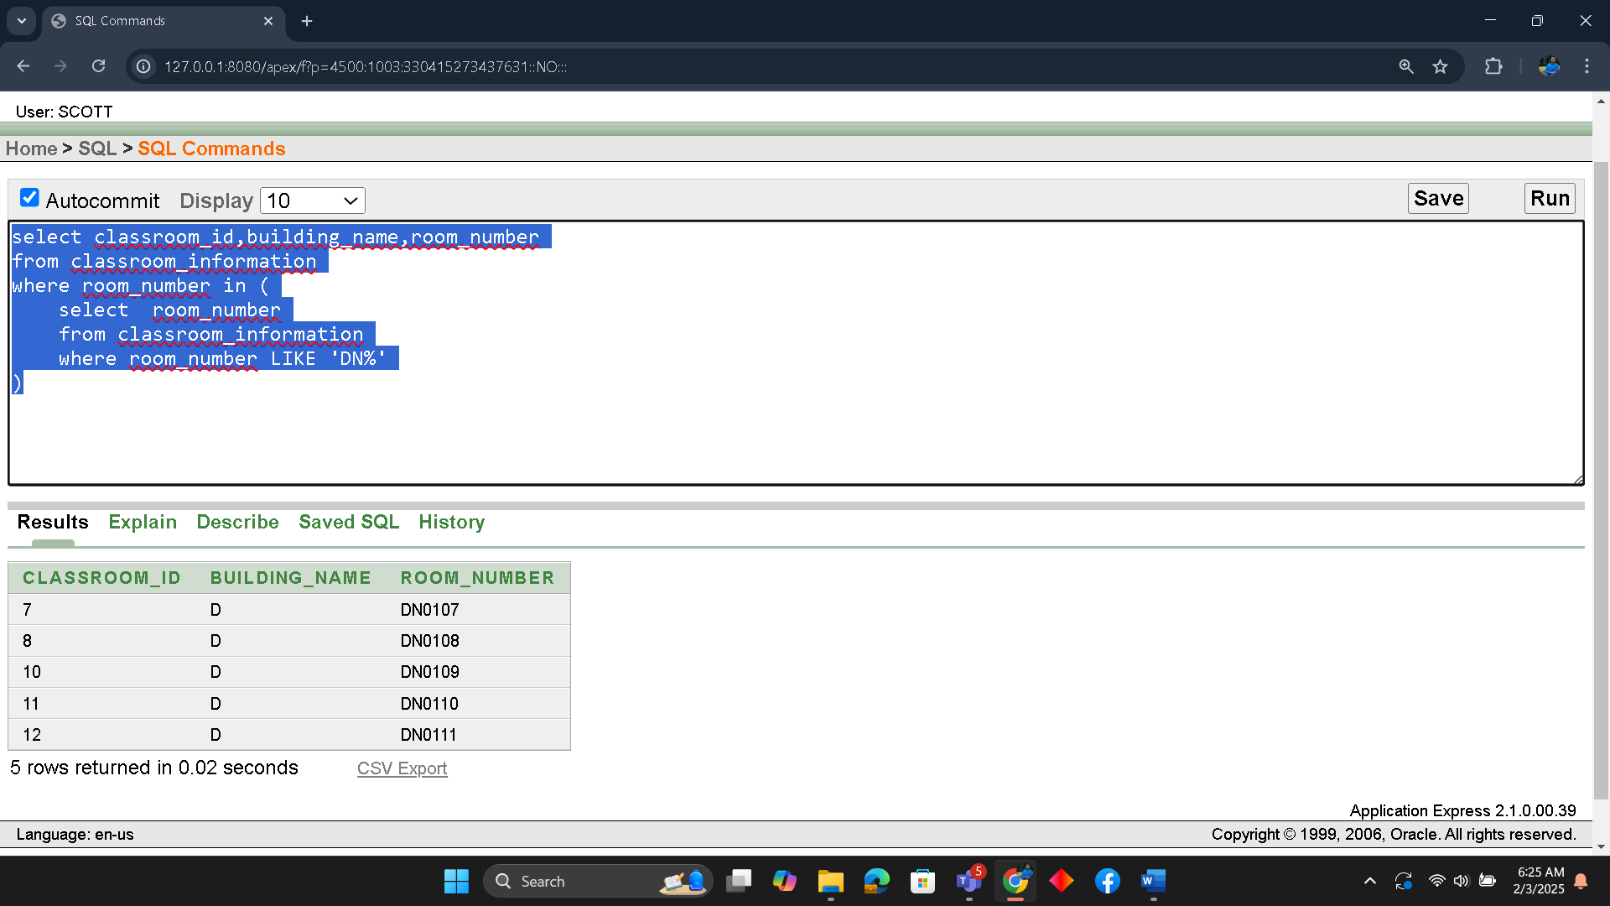

e) 4 kinds of joining

EQUIJOIN:
To retrieve student details along with their address and contact information using Equijoin.
select sa.student_id ,sa.home_no, sa.city, sc.student_phone.
from student_address sa
join student_contuct sc
on sa.student_id = sc.student_id

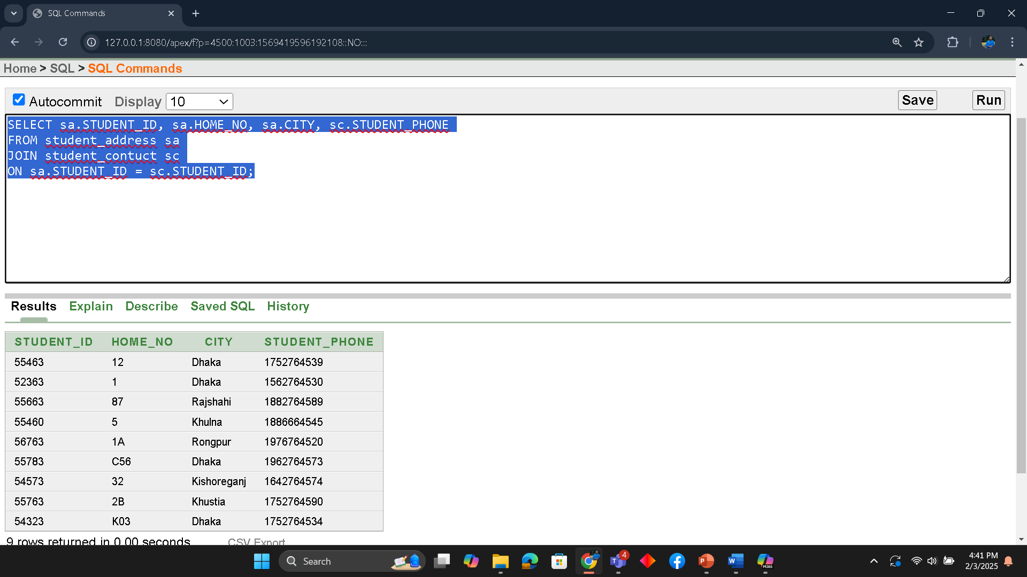

NON-EQUIJOIN:
Retrieve student IDs, names, and their city from the student_information and student_address tables for students whose STUDENT_ID falls between 52000 and 58000."
select si.student_id, si.name, sa.city
from student_information si, student_address sa
where si.student_id = sa.student_id
and si.student_id BETWEEN 52000 AND 58000;

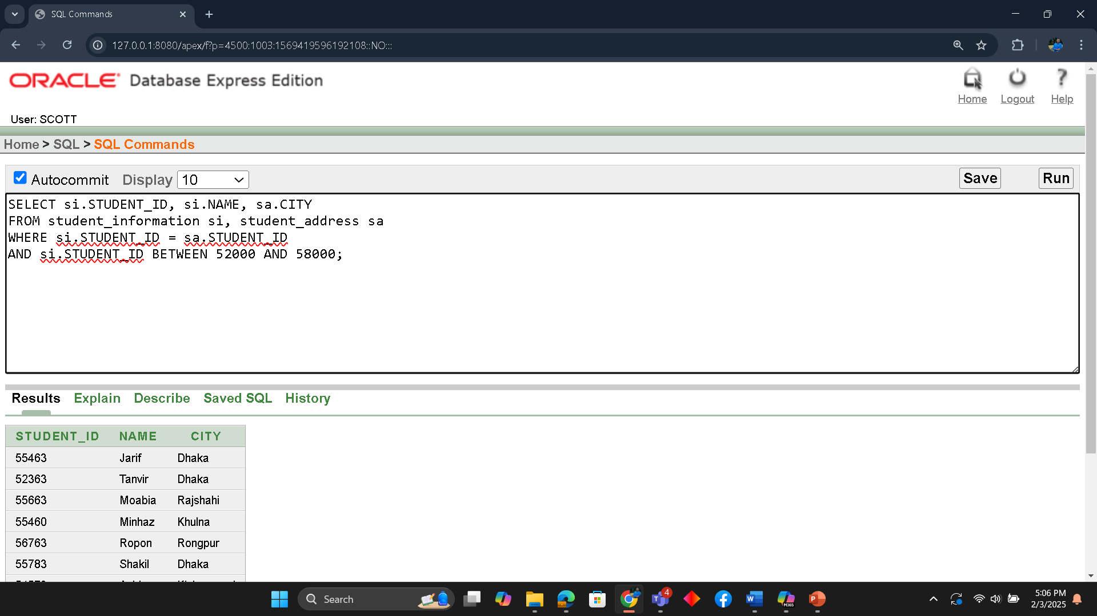

SELF JOIN :
Find students living in the sane city but different student_id.
select s1.student_id AS student1_id, s1.city AS City, s2.student_id AS student2_ID
from student_address s1
join student_address s2
on s1.city = s2.city AND s1.student_id != s2.student_id
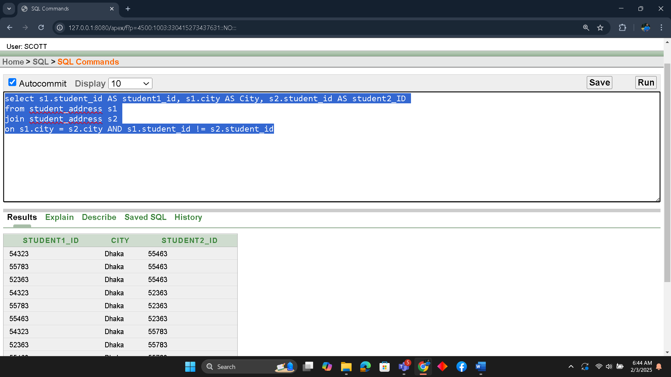

OUTER JOIN:
Write an SQL query to retrieve all department information along with classroom information, ensuring that all departments are displayed even if they don't have a matching classroom.

select d.department_id, d.department_name, d.faculty_id,
c.classroom_id, c.building_name, c.room_number
from department_information d, classroom_information c
where d.department_id = c.classroom_id(+)
order by d.department_id
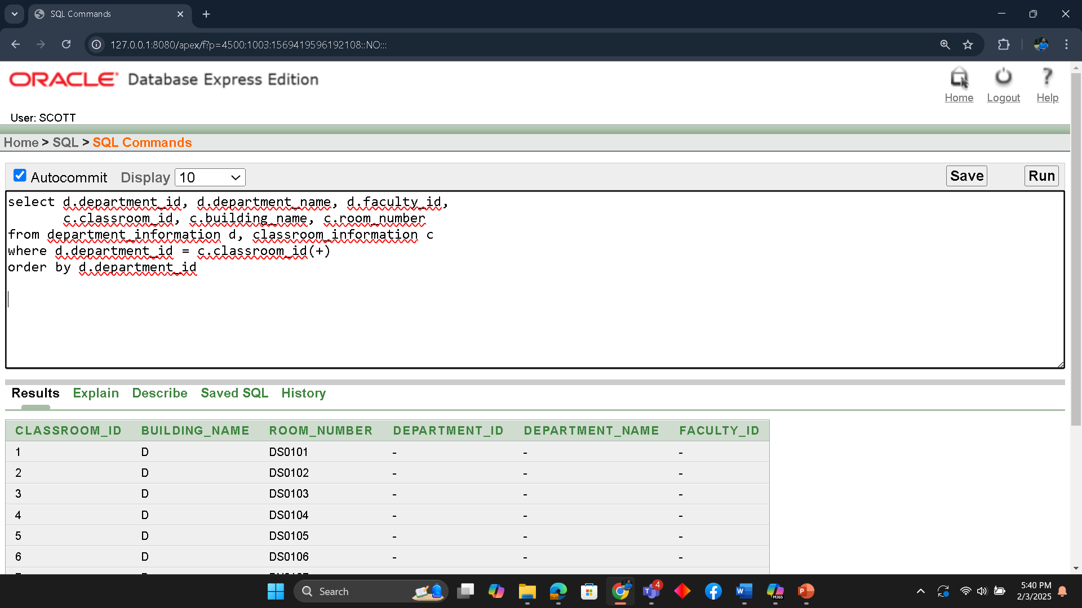

1 simple view
Create a view named sview122 that displays only students belonging to DEPARTMENT_ID = 122, showing columns NAME, STUDENT_ID, and DEPARTMENT_ID."

create view sview122 AS
select name, student_id, department_id
from student_information
where department_id = 122;
select * from sview122

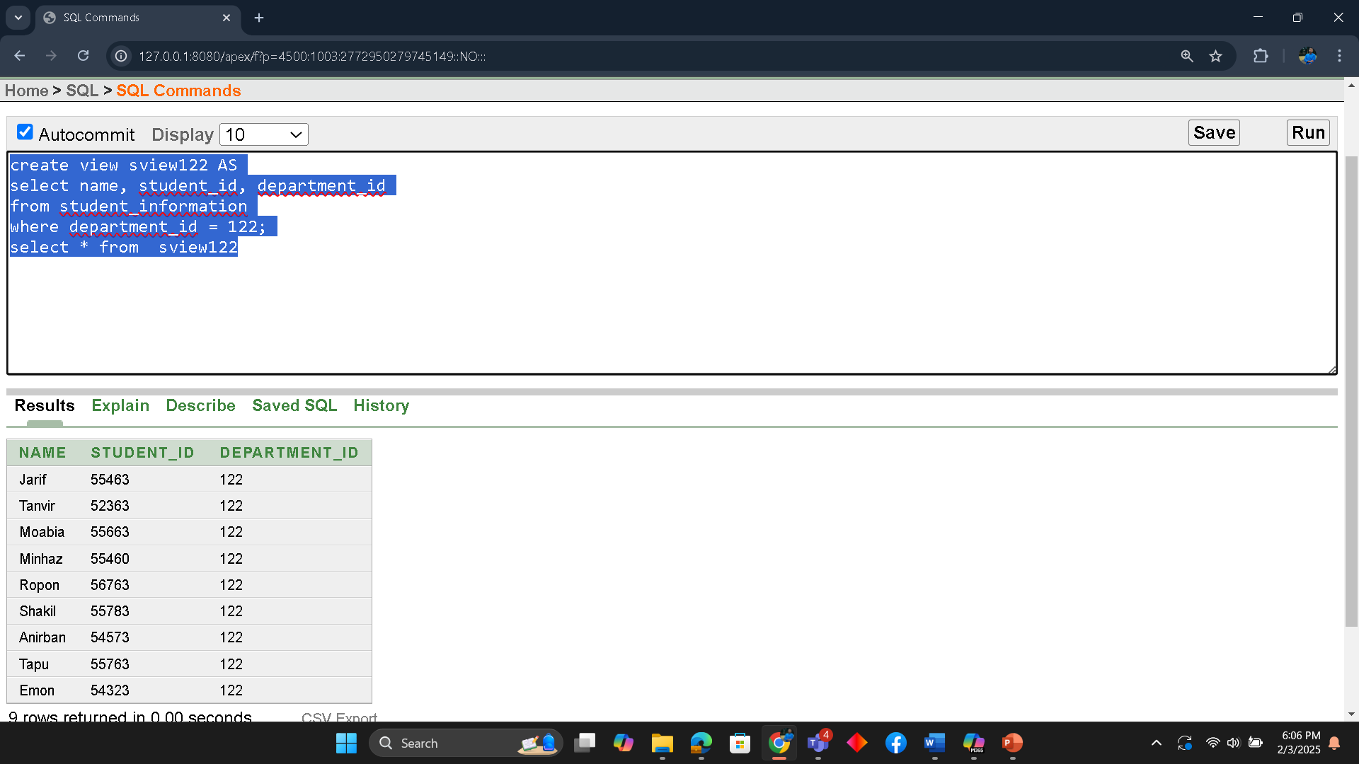

1 complex view
Create a SQL view that displays the minimum and maximum course credits for each department, grouped by department ID.
SELECT * FROM course_information;
CREATE VIEW course_summary AS
SELECT
department_id,
MIN(course_credits) AS min_credits,
MAX(course_credits) AS max_credits,
COUNT(course_id) AS total_courses
FROM course_information
GROUP BY department_id;
select * from course_summary

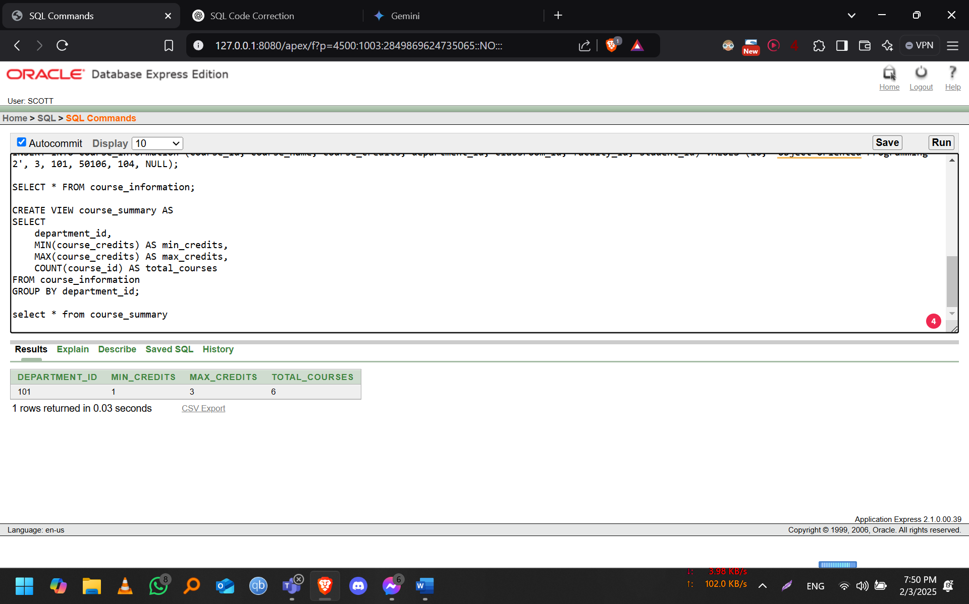

Description of a Successful DB connection

Md. Tanvir Hasan (23-54796-3)

Required Tools:
- MySQL Java Connector – Downloaded mysql-connector-j-9.2.0.jar and extracted it using WinRAR or other software. The JAR file path was set permanently to avoid ClassNotFoundException: com.mysql.cj.jdbc.Driver.
- XAMPP – A free and open-source software providing a local server environment. We used XAMPP Control Panel v3.3.0, which includes phpMyAdmin for managing MySQL databases.
Setting Up the Environment:
- Configured MySQL Connector – Ensured Class.forName("com.mysql.cj.jdbc.Driver") is correctly set in Test.java.
- Installed XAMPP and started Apache and MySQL.
- Created a Database (ums) and defined the necessary table via phpMyAdmin.
- Established Connection – Used Connection conn = DriverManager.getConnection("jdbc:mysql://localhost:3306/ums", "root", ""); to link Java with MySQL.
- Implemented Queries – Printed output using System.out.println() based on table attributes.
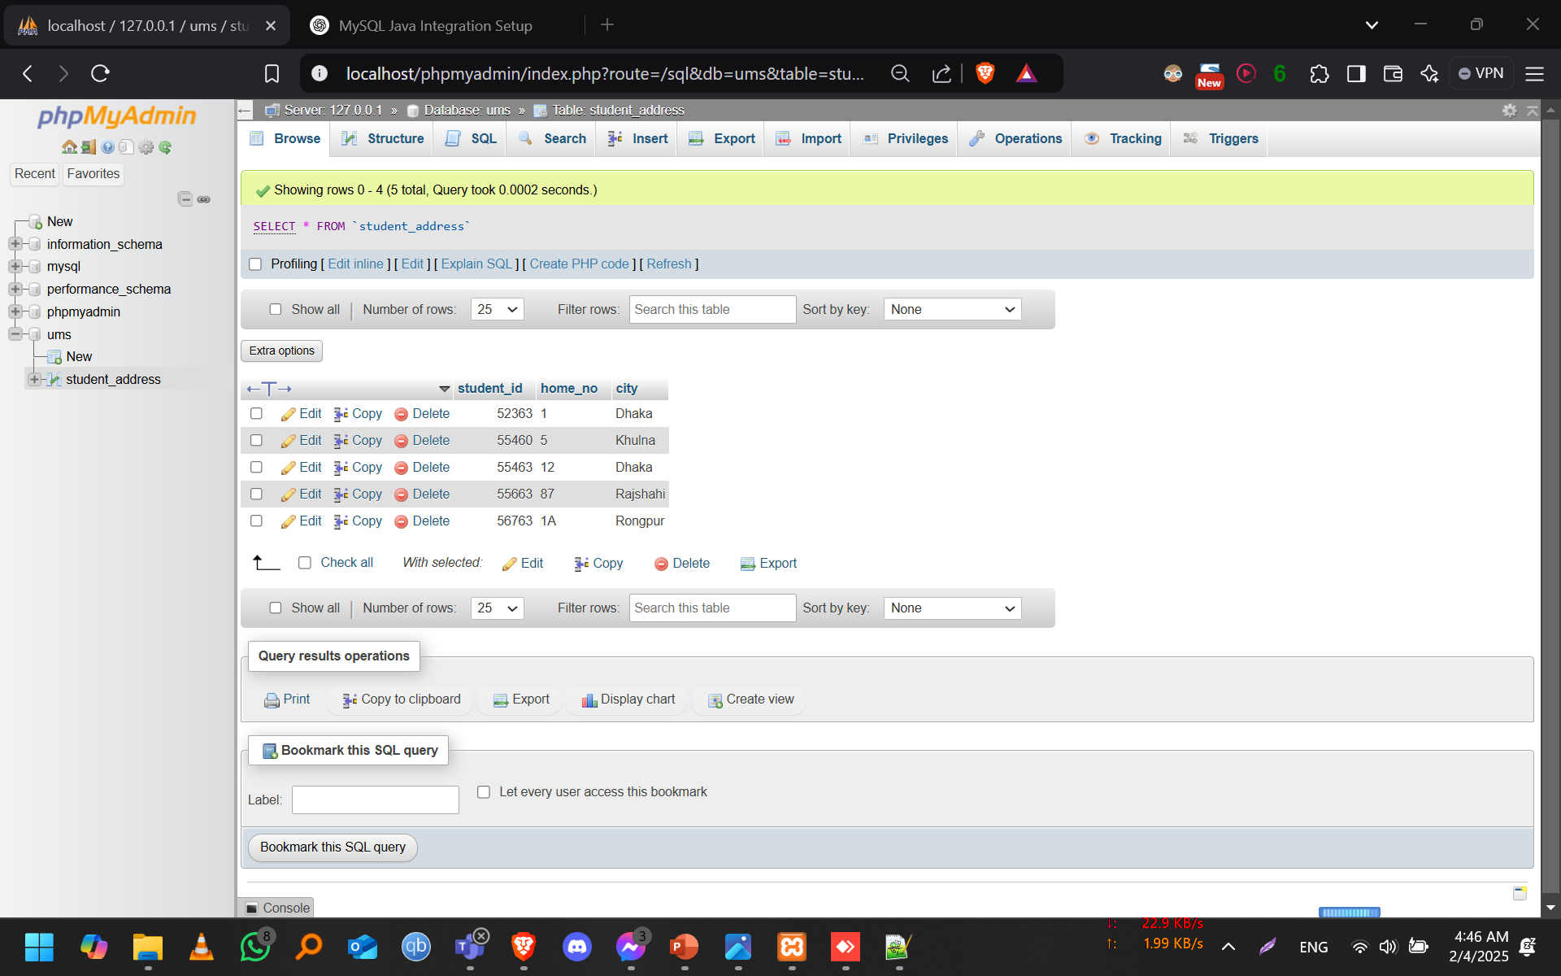
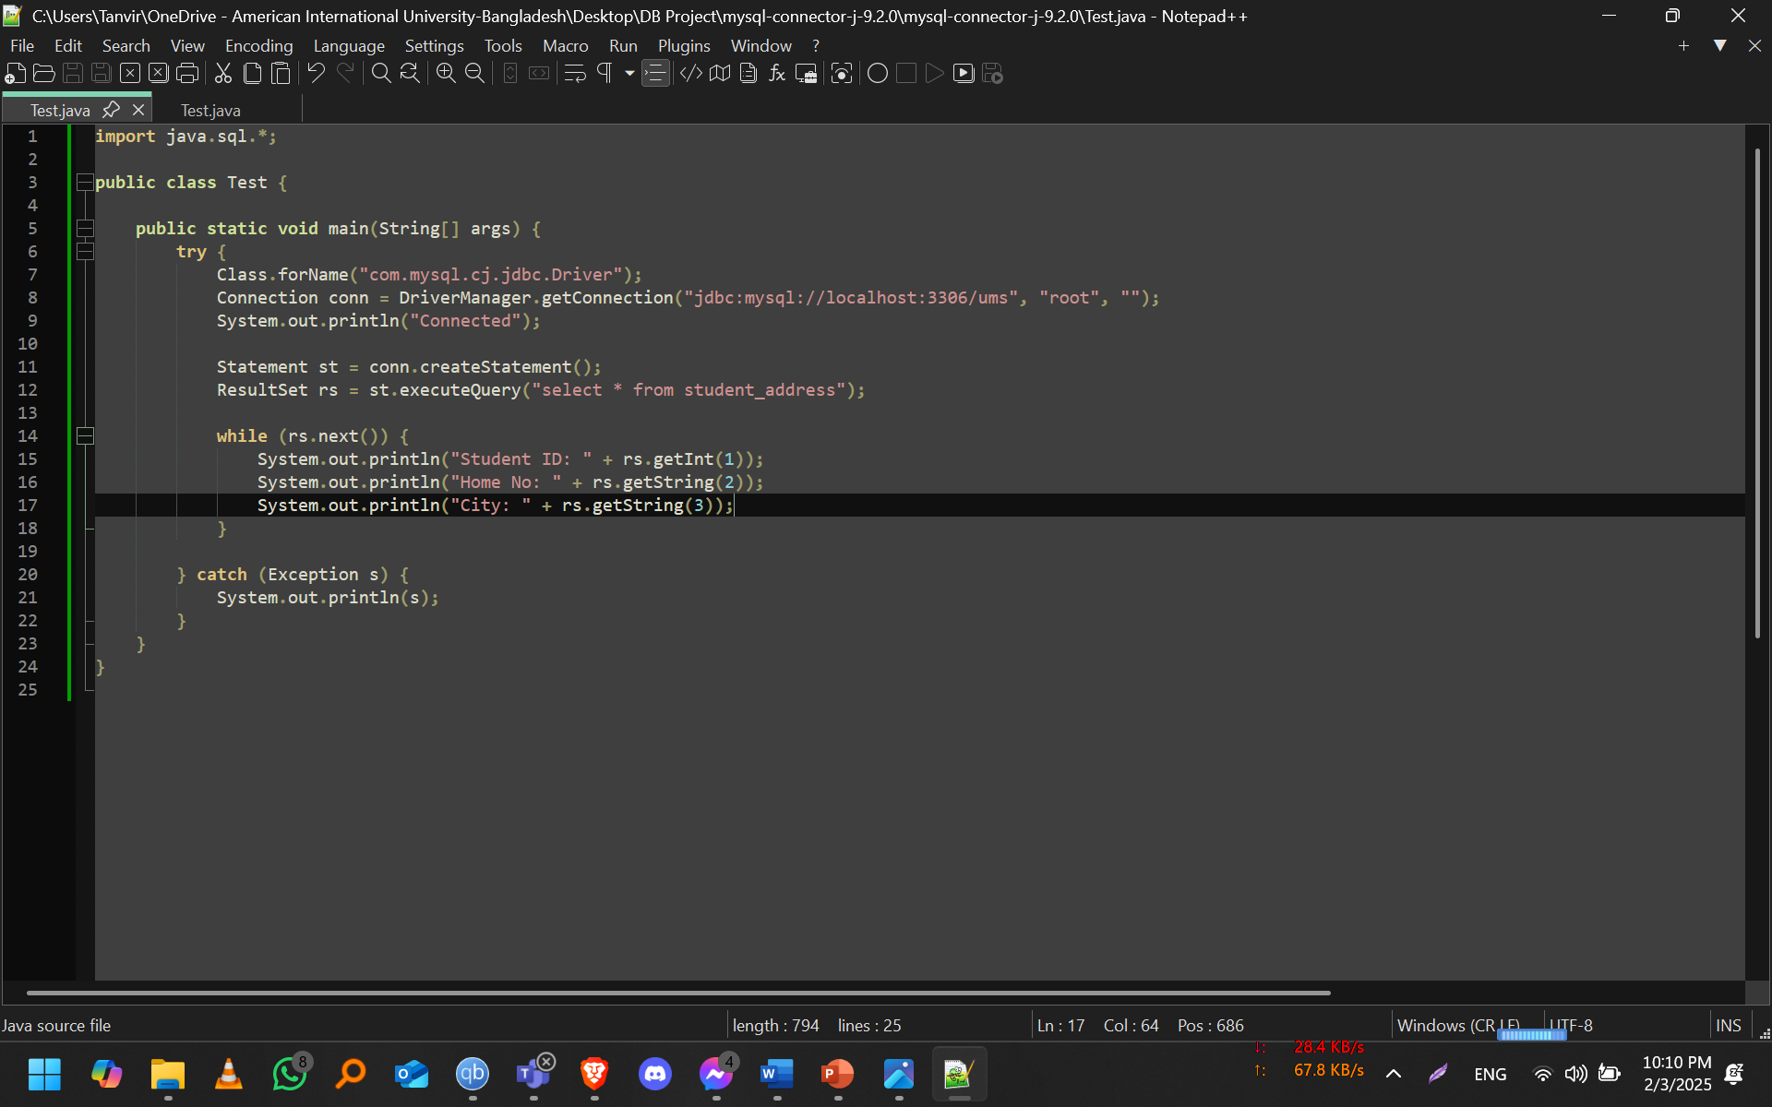
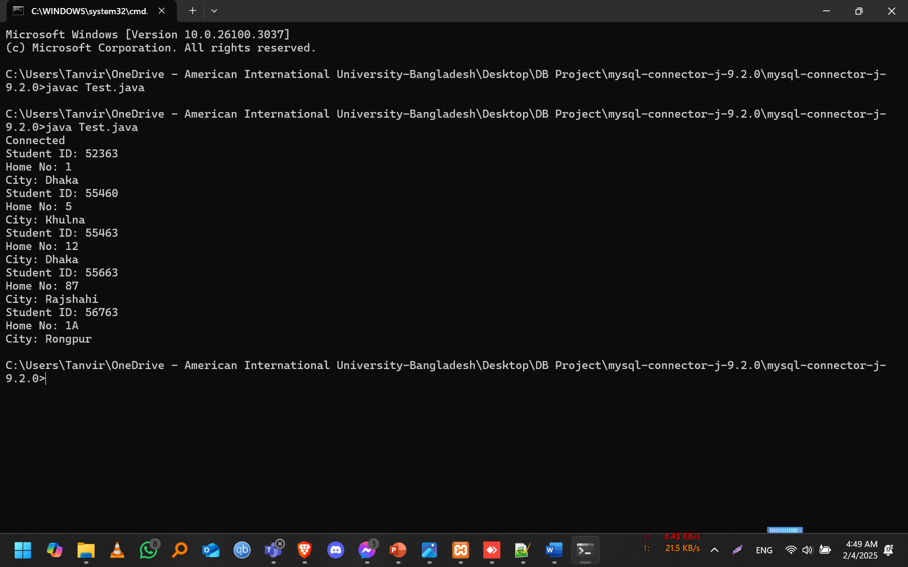

Md. Jarifur Rahman (23-55463-3)

Essential Tools:
- MySQL Java Connector – Downloaded mysql-connector-j-9.2.0.jar and extracted it using WinRAR or similar software. The JAR file path was configured permanently to prevent ClassNotFoundException: com.mysql.cj.jdbc.Driver.
- XAMPP – An open-source local server environment. We used XAMPP Control Panel v3.3.0, which includes phpMyAdmin for managing MySQL databases.
Environment Setup:
- MySQL Connector Configuration – Ensured Class.forName("com.mysql.cj.jdbc.Driver") is properly set in Test.java.
- XAMPP Installation – Installed XAMPP and started Apache and MySQL services.
- Database Creation – Set up a database (ums) and structured the required table using phpMyAdmin.
- Establishing Connection – Used Connection conn = DriverManager.getConnection("jdbc:mysql://localhost:3306/ums", "root", ""); to integrate Java with MySQL.
- Executing Queries – Printed outputs using System.out.println() based on table attributes

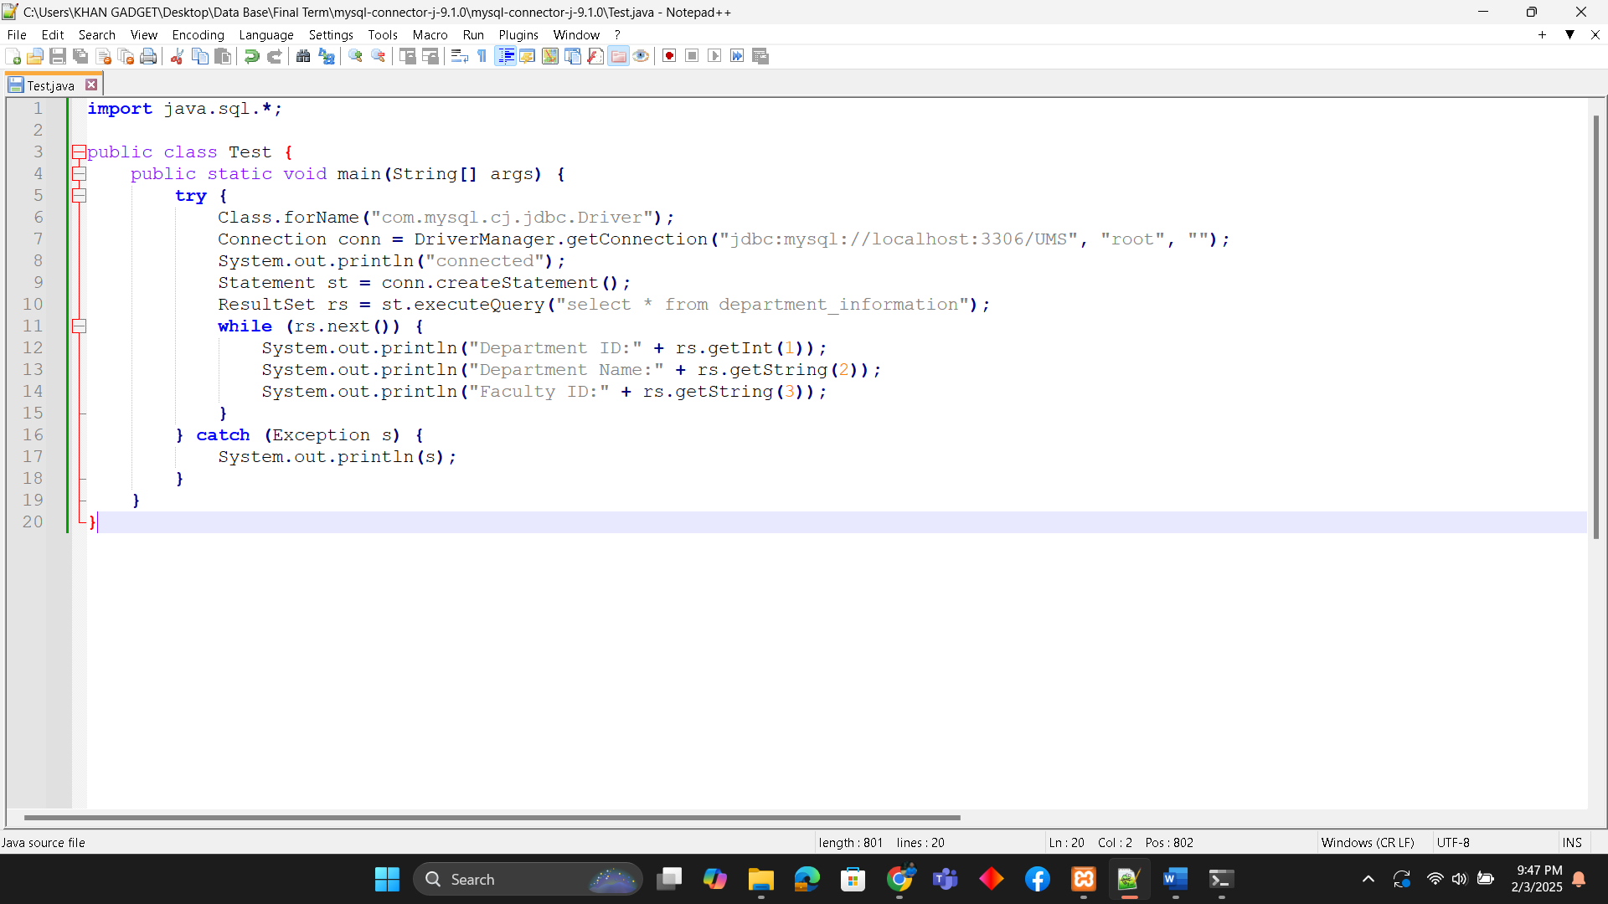

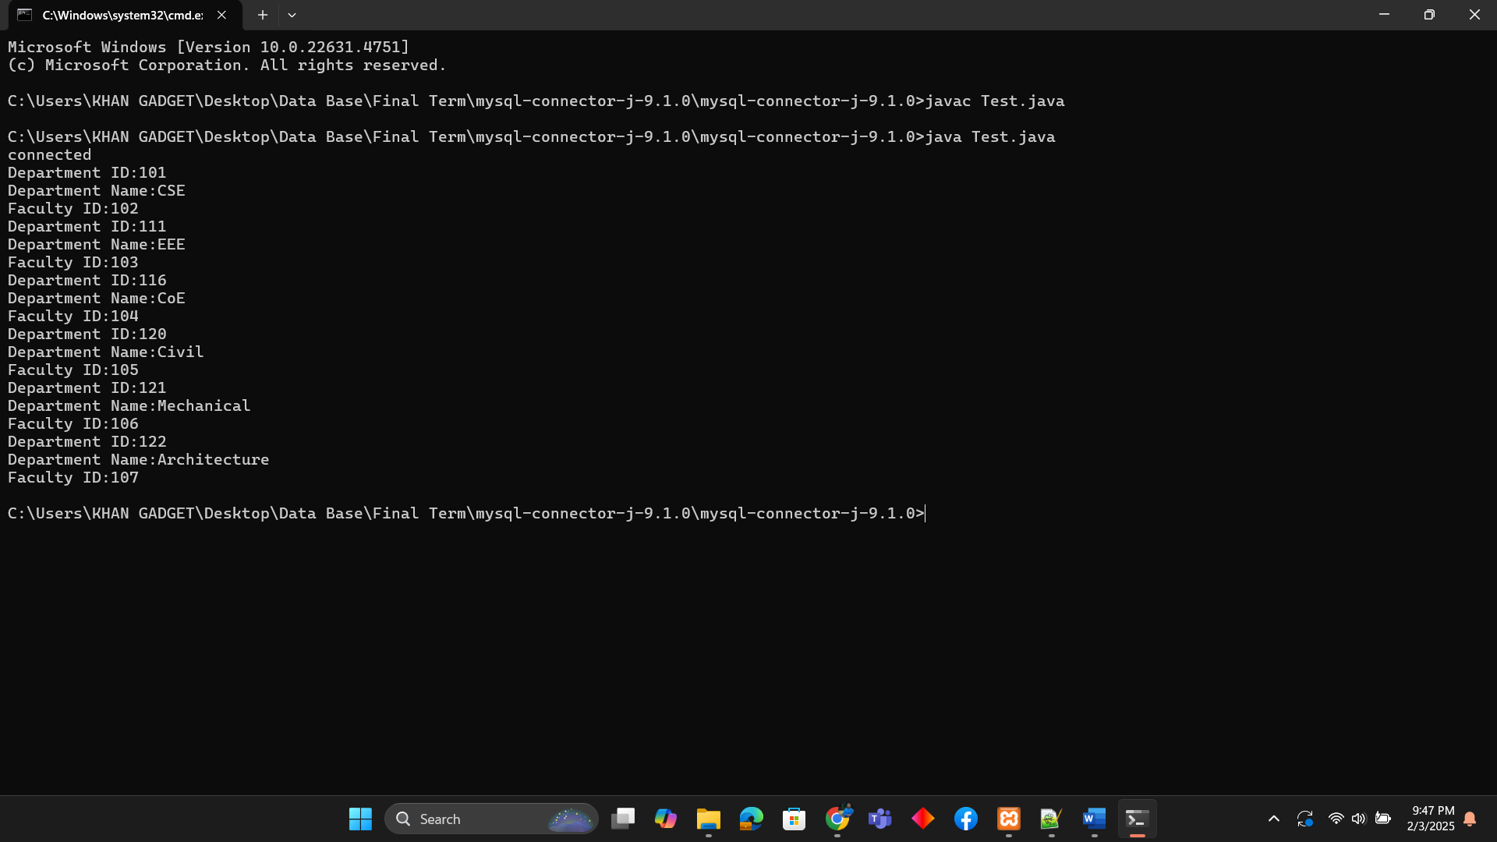

Rubia Ispa hridi (23-53606-3)
Essential Tools:
- MySQL Java Connector – Downloaded the mysql-connector-j-9.2.0.jar file and extracted it using WinRAR (or a similar tool). The JAR file path was configured permanently to avoid the ClassNotFoundException: com.mysql.cj.jdbc.Driver.
- XAMPP – Installed the open-source local server environment, XAMPP Control Panel v3.3.0, which includes phpMyAdmin for managing MySQL databases.

Environment Setup:
- MySQL Connector Configuration – Ensured that Class.forName("com.mysql.cj.jdbc.Driver") was correctly set in Test.java.
- XAMPP Installation – Installed XAMPP and started the Apache and MySQL services.
- Database Creation – Created a database named ums and structured the necessary tables using phpMyAdmin.
- Establishing Connection – Integrated Java with MySQL by using Connection conn = DriverManager.getConnection("jdbc:mysql://localhost:3306/ums", "root", "");.
- Executing Queries – Printed outputs using System.out.println() based on the attributes of the table.

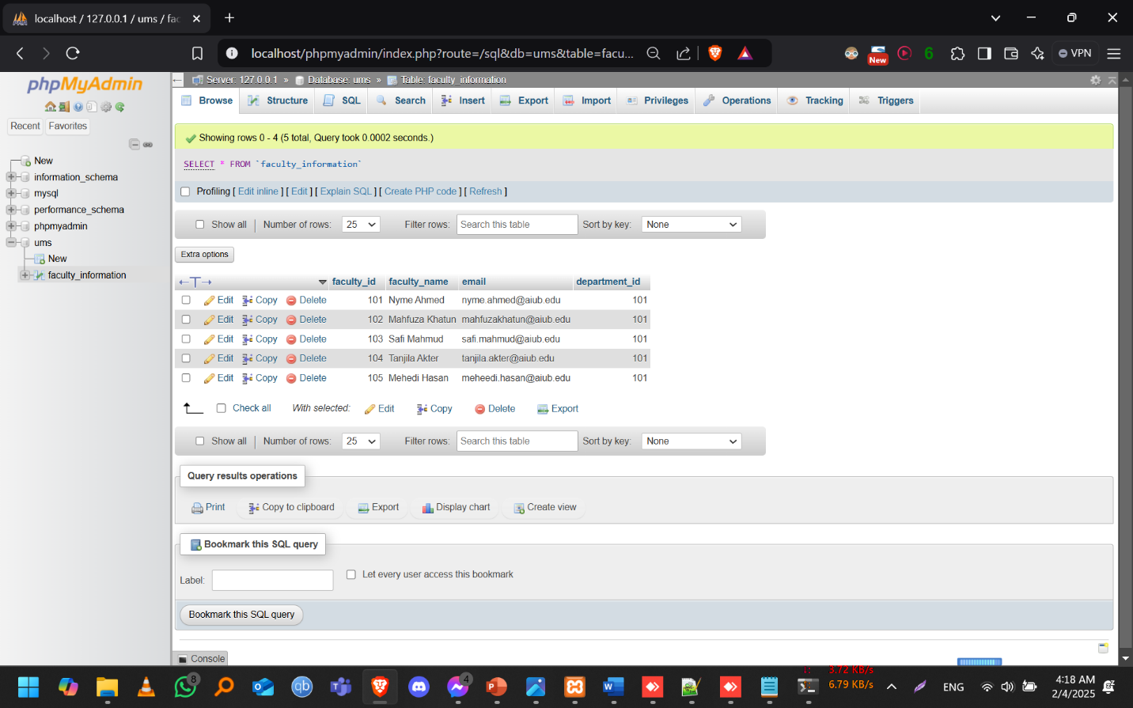

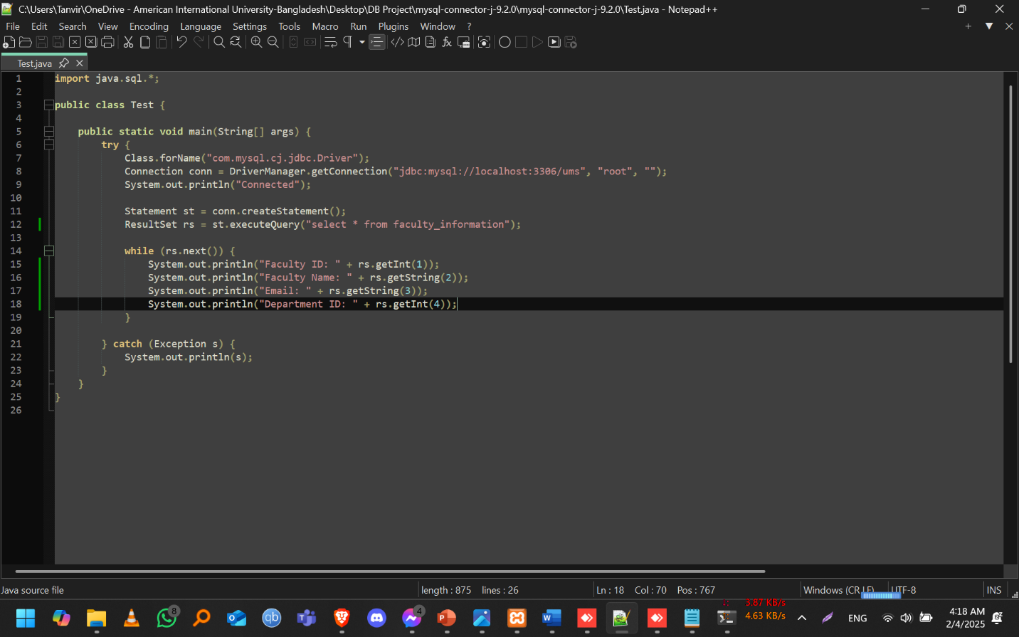
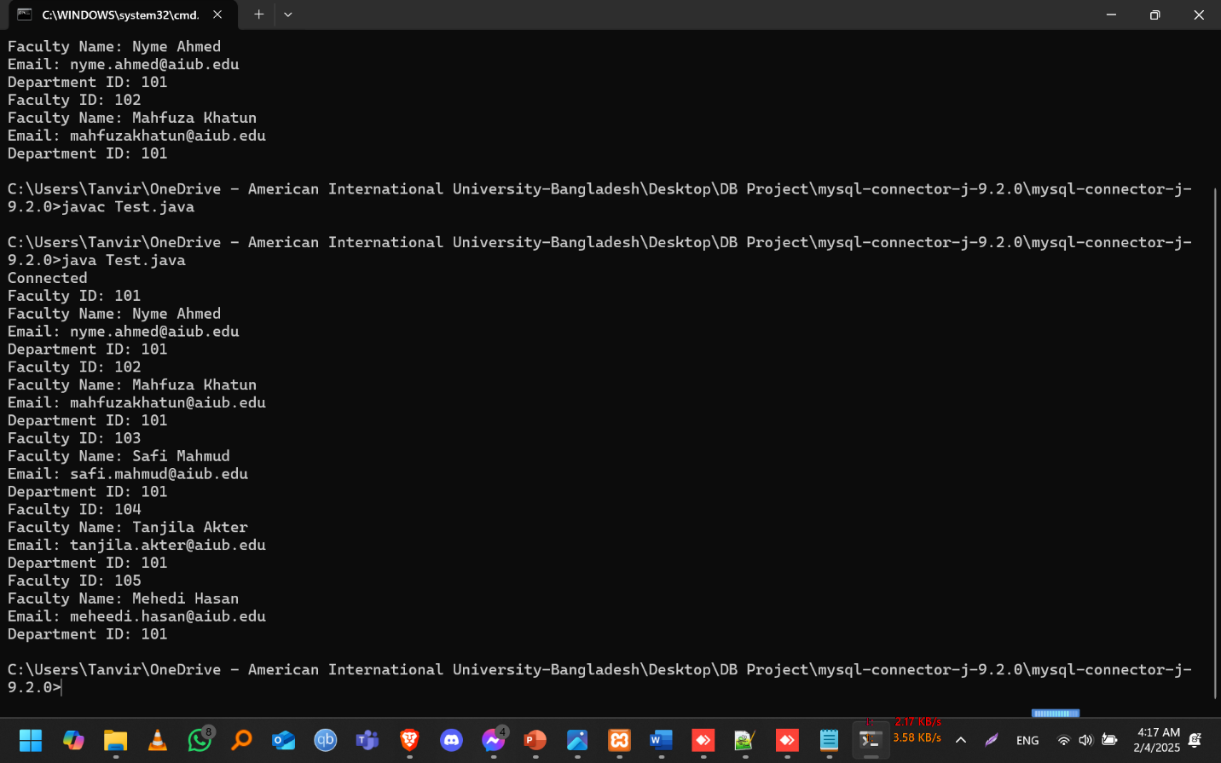

Conclusion

Future Aspects:
- Web Interface Development – Building a simple web dashboard using PHP and HTML to interact with the database easily.
- User Authentication – Adding login functionality with role-based access for students, faculty, and admins.
- Data Validation & Security – Implementing input validation and encryption techniques to prevent SQL injection.
- Automated Report Generation – Enabling automated reports for student performance, attendance, and course details.
- Cloud Integration – Moving the database to an online server for remote access and scalability.
- Backup & Recovery System – Adding an automatic backup mechanism to prevent data loss.
This project serves as a strong foundation for a fully functional University Management System and can be expanded further with additional features.

Project Summary:
This project develops a University Management System (UMS) using Oracle Database, XAMPP, and MySQL for efficient student data management. Oracle provides scalable database solutions for complex queries and data optimization, while XAMPP sets up the local server environment to manage MySQL through phpMyAdmin. The system integrates both databases using Java and JDBC, enabling smooth data interaction. Future enhancements like web and mobile integration, security upgrades, and cloud deployment will scale this system into a comprehensive university management platform.

